“Like it or not, put up with it, my beauty”
Unpunished Crimes:

Sexual Violence of the Russian Occupying Forces Against Ukrainian Women

case studies

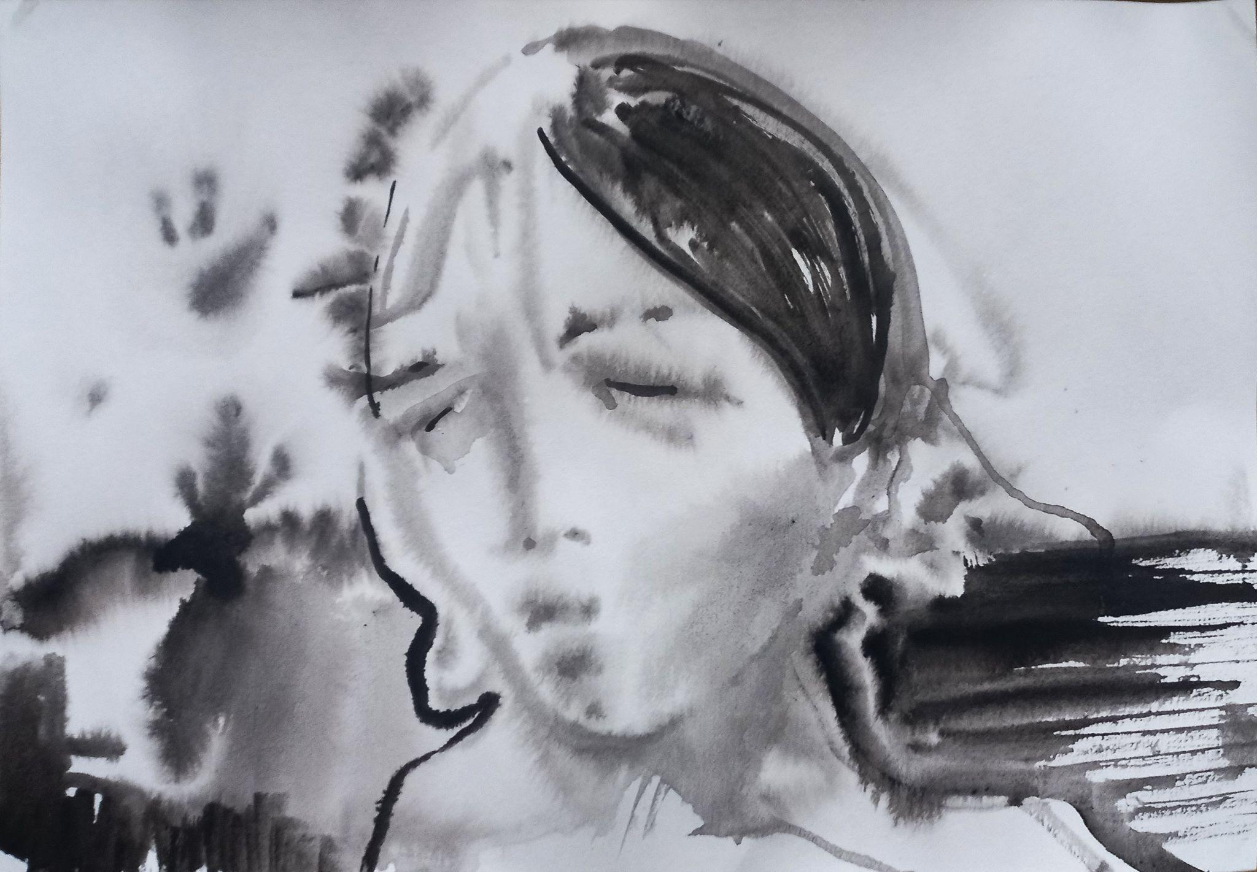
(Artist: Serhiy Zakharov)

TABLE OF CONTENTS
- Preface.
- Life on the eve of Russia’s full-scale invasion of Ukraine and during the occupation. The beginning of the occupation and 24 February.
- Legitimate fears of women during the occupation. Information from neighbors and friends about cases of conflict-related sexual violence (CRSV). Threats from representatives of the Russian occupying forces concerning CRSV.
- Circumstances surrounding the committing of crimes by Russian occupying forces:
  - At the witness’ home;
  - Elsewhere.
- Rape and CRSV committed by members of the occupying army.
- Threats against the victims and their families by representatives of the Russian occupying forces.
- Killings of victims or family members of witnesses by representatives of the Russian occupying forces.
- Cases of rape of minors and the elderly committed by representatives of the Russian occupying forces.
- Illegal detentions, torture, and sexual crimes committed by representatives of the Russian army.
  - Circumstances of the illegal detention of Ukrainian women.
  - First days of detention.
  - Violation of the bodily integrity of witnesses.
  - Conditions experienced during detention:
    - Access to personal hygiene products;
    - Access to sanitation facilities;
    - Restriction of witnesses’ access to food and water;
    - Health of witnesses and lack of medical care;
    - Temperature in the rooms where prisoners were held;
    - Isolation from the outside world.
  - Interrogations.
  - Torture:
    - Psychological torture;
    - Threat of rape;
    - Sexual violence as torture.
- The appearance and nationality of representatives of the Russian occupying forces who committed crimes against women.
- The physical condition of witnesses following the crime. Medical documents.
- The mental condition of witnesses following the crime.
- Citizens of Ukraine who are still held captive.
Appendix: А1. Legislative and regulatory framework.

- PREFACE

“Like it or not, put up with it, my beauty,” Vladimir Putin said just before the full-scale invasion of Ukraine. His obscene joke is a grim symbol of both Russia’s attitude towards Ukraine and the Russian occupying forces’ treatment of Ukrainian women. With such words, the President of Russia emboldened his troops to commit rape, normalizing the use of sexual violence as a weapon against the civilian population of the nation under attack.

The Russian army’s actions against Ukrainian women can be compared to those of the Red Army during the Second World War, as they stem from the fact that the crimes committed during various armed conflicts by Soviet and later Russian troops were never punished.

Since 2014, Russia has systematically used sexual violence in temporarily occupied Ukrainian oblasts. Ukrainian women are raped, tortured and sometimes cruelly murdered in torture chambers set up by Russians and their collaborators, all with acquiescence from Russia’s authorities and society. The internet is full of comments from “ordinary Russians” who support crimes against Ukrainian women, as well as of recordings made by Russian women who, sending their husbands off to war, encourage them to rape Ukrainian women.

In our report, we give voice to more than sixty Ukrainian women from regions affected by the Russian aggression. The testimonies are fully anonymized. For safety reasons, we do not provide any data concerning these women that could lead to their identification. Our protagonists – women of all ages – come from various regions of the country and different social classes, but they have one thing in common: they became stuck in Russian-occupied territories and fell victim to violence perpetrated by Russian soldiers in the years 2014–2022.

With the full-scale invasion of Ukraine, the number of Russian crimes against women has increased. The actual extent of the damage will be known only after the complete deoccupation of Ukraine. All we have today are the testimonies of the survivors. Their accounts are terrifying: women are dragged out of their homes at night, stripped naked and beaten with rifle butts; mothers are raped together with their daughters; elderly women are forced to perform oral sex; both male and female captives are gang raped. The brutality of Russian servicemen is striking – while forcing their victims to participate in sexual acts, they beat them, knock out their teeth and cut them with knives. As one of the victims of sexual violence in Russian captivity said, “It was simply a form of torture… They did not derive sexual pleasure from it.”

When we document Russian crimes in the liberated territories, we see that one of the tools used by the Russian army to control the local populace is fear of sexual violence. Women are afraid to leave their homes, wary of any contact with the occupiers. The threat of rape is widely used during interrogations to intimidate the victims. As we see from the testimonies, when forced sexual intercourse does take place, the victims are powerless against the perpetrators; they fear for themselves and for their families, they dread the possible return of sex offenders, and they are unable to protect themselves against the armed attackers. All this indicates that while Russia establishes administrative structures in the occupied territories, ostensibly to protect law and order, rape remains an element of the occupiers’ apparatus of violence.

Towards the end of our report we quote one of the victims – a woman over 75 years old, a retired teacher. During documentation, she told us that she had worked hard all her life to earn the respect of her community. “I never thought that this could happen to me. I want to shout at the whole world.” Sexual violence committed by the Russian troops is not spontaneous; it is part of the Russian strategy of terror against Ukraine, which includes for instance mass missile attacks on Ukrainian cities. This report was written to help the victims “shout at the whole world.”

Monika Andruszewska
Report coordinator, trench journalist
Report methodology

The report of the Raphael Lemkin Center for Documenting Russian Crimes in Ukraine was prepared on the basis of field research in the oblasts of Kyiv, Donetsk, Sumy, Chernihiv, Dnipropetrovsk, Kherson and Zaporizhzhia. Victims from the temporarily occupied parts of the Donetsk and Luhansk oblasts testified in the territory controlled by Ukraine.

The report contains the testimonies of women who suffered at various stages of the hostilities, both during Russia’s full-scale invasion of Ukraine and in the years 2014–2022.

The interviews were carried out in person in the victims’ places of residence, with due regard for the interviewees’ psychological comfort.

The testimonies were collected between April 2022 and February 2024.

The testimonies were gathered in compliance with the requirements of the Personal Data Protection Act. Each participant was informed in advance why the information was being collected and where the data would be stored.

In accordance with previous arrangements, all testimonies were anonymized, because the victims’ safety and protection of their privacy are of the utmost importance. The letter W stands for witness, and the following age categories are provided: M – minor, 18+, 25+, 35+, 45+, 55+, 65+, 75+.

We would like to note that as a brutal war is raging in Ukraine, the witnesses who agreed to share their stories showed incredible courage.

Testimonies

- Life on the eve of Russia’s full-scale invasion of Ukraine and during the occupation. The beginning of the occupation and 24 February.

W58(75+): “We realized [in 2014 – ed.] that this was war, and that this was just the beginning (…). We didn’t want that plague to spread (…).”

The occupation of parts of the Donetsk and Luhansk oblasts began in spring 2014, after the annexation of Crimea, with the deployment of Russian troops in Ukraine. Russian soldiers and their collaborators gained access to local weapons depots, erected roadblocks, occupied government buildings and started to murder both representatives of the local authorities and patriotic residents. In the occupied territories, Russia’s puppet states proclaimed the so-called “Donetsk People’s Republic” and “Luhansk People’s Republic”.

W53(55+): “(…) I saw the broadcast from Crimea on TV. I saw Russia’s little green men standing calmly, guns in hand, in Ukrainian Crimea. In the territory of Ukraine… It was a horrible feeling, I was just sitting there, shocked. Then I told my children that very scary times are probably ahead.”

W53(55+): “May brought some kind of phantasmagoria. Whenever I turned on the TV, all I saw were waves of propaganda. There were endless announcements about the advent of Russia. Your lives will be wonderful, we were told, because Russia will quadruple retirement pensions, Russia will give the Donbas cheap petrol. I tried to put up some resistance, because I knew that the only free cheese is in the mousetrap.”

W53(55+): “(…) The police stopped working, the whole policing system was dismantled (…). Strange crowds of people appeared at the police station. There were open bottles of vodka on the threshold. It was a strange and frightening sight…”

W61(25+): “Strange people gathered in the streets; they were marching, shouting ‘Russia!’ and waving their flags. Then military vehicles appeared on the streets… There was some shooting… All of this was happening very fast, it was frightening and incomprehensible.”

W61(25+): “Once I had an embroidered shirt on… I remember that as I walked down the street, the Russian servicemen at the checkpoints were watching me closely, they were staring at me… But my mother said, ‘Don’t worry, keep your head up. This is our cultural heritage! There is nothing to be afraid of!’”

W61(25+): “(…) Everything changes dramatically (…). You have to leave everything behind, abandon your family home – you simply have to, in order to have a future, a safe life, away from all of this…”

W61(25+): “I left mainly because, first, my life was in danger, and second, everything was turning lawless, and nobody knew what lay in store for us…”

W61(25+): “The occupied territories of Ukraine have filled with cruel invaders, who are capable only of destruction, who either killed or imprisoned all normal and educated people. They destroy everything that is connected with Ukraine: books on art, all publications in Ukrainian. These occupiers don’t understand creativity. This place is somehow dead…”

W53(55+): “The spring of 2014 split our lives in two. I was a good homemaker, a beloved wife, a happy mother – and we lived quietly in our family town… And then the Russians came and destroyed everything. They took our houses, possessions, jobs. In the occupied territories of the Donbas, the Russians brutally persecuted the unruly residents. Russian mercenaries arrested patriotic Ukrainian women and subjected them to various forms of torture. Russia not only caused us physical suffering, but also put an end to our happy lives! We had to rebuild our lives from scratch.”

W53(55+): “Having survived tortures and violence in 2014, having lost my house and my business, having made a great effort to rebuild my life, I was woken up by explosions on 24 February [2022 – ed.]. ‘I won’t survive it a second time… I’m not strong enough…’”

On the dawn of 24 February 2022, Russia launched a full-scale aggression against Ukraine, commencing missile strikes across its entire territory. For the majority of witnesses interviewed by the Raphael Lemkin Center for Documenting Russian Crimes in Ukraine, the first impression connected with Russia’s full-scale invasion of Ukraine was the sound of explosions.

W20(55+): “Wake up, the war has started! The Russians are bombing Ukraine!”

W9(55+): “I heard the explosions on 24 February… They woke me up… I realized that this was war…”

W15(45+): “Early in the morning, at about half past five… My mother called and started crying… I didn’t understand what was wrong. I thought that something bad had happened, that some family member had died. I said, ‘Mom, what is it?’ She couldn’t speak for her tears. I asked again, ‘Mom, what is it? Has someone died?’ She answered, ‘No, a war has begun…’”

W23(75+): “My granddaughter came running to me, shouting, ‘War! War!’”

W43(55+): “We weren’t expecting this! They came so suddenly, like vipers…”

W31(25+): “It was terrifying. At that moment, at five in the morning, life ended. You don’t know what will come next, you don’t know what will happen… Your mother is 40 kilometers away, trying to get back home… It is difficult. It was truly terrifying… I don’t understand… Because you don’t know what will happen tomorrow or whether there will be a tomorrow…”

The beginning of the occupation

The occupation of the territories where the witnesses lived at the time began in the first days – sometimes even in the first hours – of Russia’s full-scale invasion of Ukraine.

W22(45+): “Russian convoys would pass through (…). People started to leave… There were planes overhead, there were explosions…”

W44(75+): “They were walking under our windows with their machine guns, shooting… There were tanks under our windows… All I could think about was, ‘Will they hit or miss? Will we survive or die?’”

W21(55+): “At first they [Russian occupying forces – ed.] were shooting almost under our windows… The house was shaking…”

W9(55+): “Even during the shelling we felt safer than after the Russian troops entered.”

W24(35+): “(…) Fear (…). You go to bed and you pray, you wake up and you pray again…”

W46(35+): “(…) It was horrible, really horrible; you walk down the street and they pass you on the street in their balaclavas, with only their eyes visible… And you don’t understand what those eyes mean, whether they want to kill you or abduct you…”

Almost all witnesses mention that in the first days of the occupation, Russian troops began looting private homes. The owners evacuated for safety reasons.

W21(55+): “First they took everything from the empty houses, including panties…”

W23(75+): “When someone left, they would run to their house like predators… They took everything… They even stole women’s underwear from one of the houses.”

Having looted the empty houses, Russian troops began to rob those houses whose owners were still present.

W25(25+): “Sometime in the second week, they began to go from door to door… They claimed to be protecting us…”

W20(55+): “They took people’s cars [to move the spoils – ed.], they stole cars… They got drunk where they were staying…”

W25(25+): “Someone told them that we had a car. So they took our car…”

W23(75+): “They took away our car hauler and our trailer, they stole everything…”

W20(55+): “My neighbor’s house was ‘the most comfortable’, so they moved in there… There were so many of them… They broke windows and doors with machine guns… I was afraid, I ran away, fearing that they would come and kill me…”

According to some eyewitnesses interviewed by employees of the Raphael Lemkin Center for Documenting Russian Crimes in Ukraine, the sheer scale of the break-ins was one of the reasons why many people, especially the elderly, were afraid to leave their property unattended and stayed in the occupied territories despite danger to their lives.

W53(55+): “I said that I couldn’t leave my house unattended. I knew that it would be robbed as soon as I left. I had three cats, a shepherd dog, and a large beautiful fish tank. I wasn’t going to abandon living creatures and just leave. Perhaps at the time I wasn’t fully aware of the danger…”

W23(75+): “This is why I didn’t leave… I wanted to keep everything I had earned and gathered over these sixty years…”

With time, the Russian occupying forces began to restrict the free movement of civilians in the occupied territories.

W22(45+): “During the occupation we couldn’t even leave our homes.”

W23(75+): “There was a sniper at the roof of the school… I was afraid to go into the garden.”

W46(35+): “I walk down the street alone – a woman with three children… Alone with three children… The street is empty… They (Russian occupiers) drive by us, so we turn into an alley to escape, but they turn around and follow us, and then stop at some distance… There is nowhere to escape or to hide. I tell my children, ‘Be quiet, don’t look at them and hurry up.’ I can say that we have never walked so fast and quietly before. We scurry along, but they are waiting by their vehicle, pointing their guns at us… They were aiming their guns at our little group. I look and see that they are all aiming their guns at us… Fear, horror, confusion… ‘Why are you aiming your guns at the children?’ I was wearing plain clothes, as were the children… We were coming back from the orthodox church. ‘And you’re standing there, you’re not alone, you’re standing there and pointing your gun at us…’”

W25(25+): “Our neighbors said that someone went out to the street and got shot… We didn’t dare go out. (…) We heard various stories… A man was shot together with his son and his dog, and we thought that they would shoot us as well…”

W23(75+): “One man… He sneaked out at night to visit his daughter. They saw him. They caught him and beat him. Then they took him to his home and hanged him there.”

In the temporarily controlled territories, the Russian occupying forces restricted access to communication.

W46(35+): “(…) It was better to burn your phone, because they would approach you and say, ‘Where is your phone?’”

W25(25+): “(…) [Russian troops – ed.] took our phones (…).”

W20(55+): “At first I was scared…When they came for a search, they told me not to leave my house… There was no signal, I couldn’t make a call. They set up their headquarters and installed antennas…Maybe they were jamming communications… I lived in fear 24 hours a day…”

W25(25+): “They came and said that somewhere from our house a signal (radio frequency) was sent and it was ‘detected.’ They gathered us in one room, there were six of us. They told me to sit next to them and then they interrogated us one by one: ‘Tell me who did this or you’ll all be dead.’ They threatened us with their guns… They were all drunk… (…) ‘Stand in line. I will kill you with one bullet.’ We didn’t stand in line, and there was a commotion… All we did was call our families…”

The Russian troops terrorized the local populace with constant searches for weapons and manhunts for patriotic civilians and Ukrainian soldiers; the Russians illegally detained those they considered suspicious.

W20(55+): “They turned everything upside down. They were looking for ‘Ukrops.’ The first time, six men came: they were masked and wore the ribbons of St. George. They rummaged through the contents of all rooms and cupboards. They inspected all the buildings…”

W23(75+): “At the house of one man’s mother they found an ID card of an ATO soldier [the victim’s son served with the Ukrainian army during the Anti-Terrorist Operation in the east of Ukraine in the years 2014–2018 – ed.]. There was a Buryat there who shouted, ‘I’ll kill you like a dog!’”

W23(75+): “They would come for, as they called it, ‘a scheduled inspection’ a few times a week. They would come to my room in search for weapons, they would go up to the attic…”

W25(25+): “(…) They were simply trying to find out what they could do to whom (…).”

W14(45+): “Every time we went to bed, we didn’t know whether we would wake up or not… The situation was such that they could enter our yard at any time, shoot us and leave… And nobody would answer for it…”

W22(45+): “My husband’s weapon was discovered… They shot at me… Because I didn’t tell them where it was. They said that a person could be killed with that weapon.”

W30(55+): “Thank God we sent away the children. I wanted to leave, I said, ‘Let’s go… I want to leave, I’m terribly scared…’ But my husband replied, ‘If I am taken captive, they won’t spare me. You go!’”

W9(55+): “A few people would disappear almost every day…”

W23(75+): They put bags on the men’s heads… We saw how cruel and callous they were… They wanted to humiliate our men. They took them to the neighboring village. They interrogated them, beat and ridiculed them…”

In order to intimidate the local populace, the Russian occupying forces demonstratively displayed the results of their crimes.

W5(M): “There were dead bodies in the street… No one came to collect them… My neighbors… There were many people I knew…”

W43(55+): “A lot of people disappeared. It is only now that we are finding and identifying the bodies.”

3. Legitimate fears of women during the occupation. Information from neighbors and friends about cases of conflict-related sexual violence (CRSV). Threats from representatives of the Russian occupying forces concerning CRSV.

Since the first days of the occupation, Ukrainian women in the territories temporarily controlled by the Russian army were exposed to acts of sexual violence. The Russian army sought to create an information blockade, but news of such cases spread among the local residents.

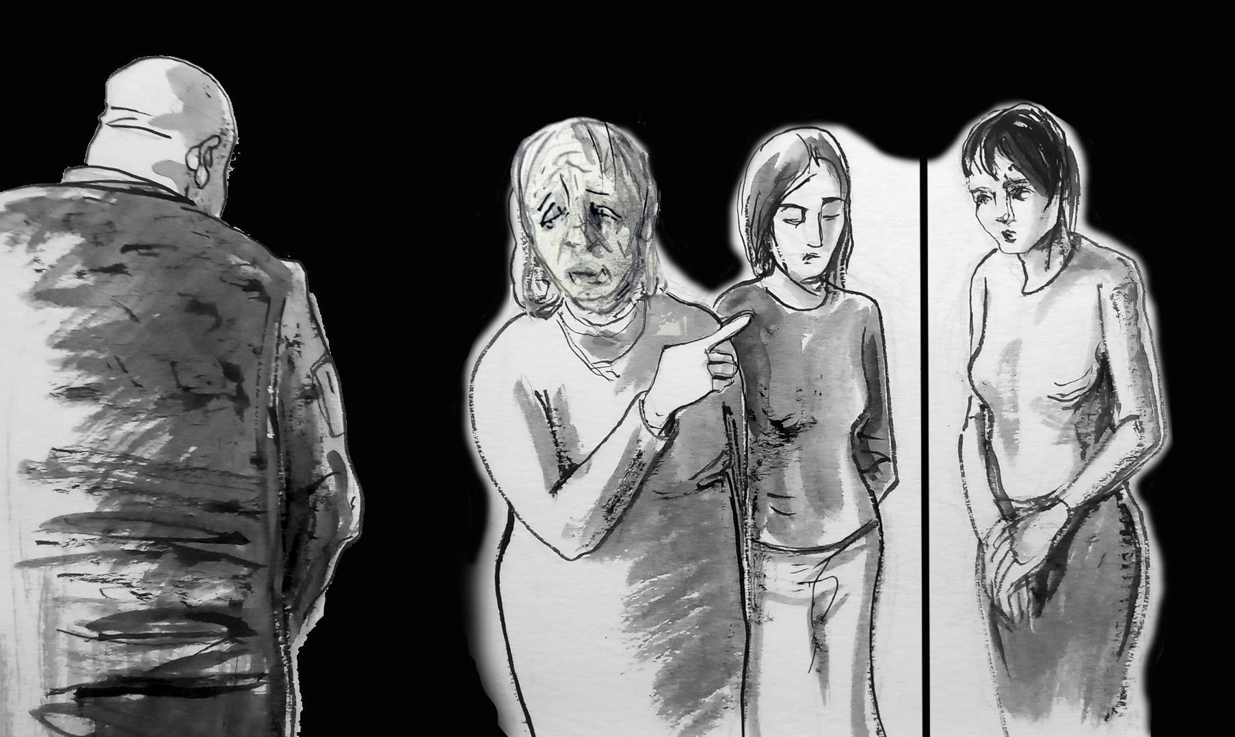

Fig. 1: “Of the two women, one was her daughter, the other – daughter-in-law. She pointed to her daughter-in-law…” (artist: Serhiy Zakharov)

W32(35+): “(…) I will tell you about one such incident: there was a large family, and there were two young women (…). That woman was told, ‘either you choose one or we will pick ourselves…’ Of the two women, one was daughter, the other – daughter-in-law. She pointed to her daughter-in-law… It happened in front of everybody… The women were of the same age, they were young and beautiful… And that soldier said, ‘choose one or we will pick ourselves…’ That woman saved her daughter and pointed to her daughter-in-law, and the daughter-in-law had two small children…”

W23(75+): “There was a woman who worked at the store. She had two sons. Later I learned that she had been raped…”

W4(35+): “An 18-year-old girl was raped. She lived with her grandmother. There was a family with four children, and the oldest daughter was raped and shot.”

W47(55+): “(…) I cried and screamed when the Russians came… He said that he killed my neighbor, and he pointed to the townhouse where it had happened – she was laying there, naked, in front of my house… They paraded her around… She did not submit to him, so he hit her in the head and she fainted. Then he cut her throat, and then again he cut something in her throat to finish her off…” [the Russian soldier described how the witness’ neighbor was raped and killed – ed.]

W49(35+): “(…) There was a woman who got raped in front of her child (…).”

W22(45+): “On the day when they took me… There was a woman, they raped and killed her… They told me where they buried her body. They found her and then buried her again.”

Women in the occupied territories tried to avoid going outside, instead hiding in their homes and basements.

W7(18+): “Once I got out – I was unwell, it was such a confined space… [in the basement – ed.]. There were [Russian – ed.] soldiers. I realized that one of them was their commander, because they obeyed him and he had a radio transmitter. He advised me not to come out again when the troops were nearby, because he had heard of the first instances of rape…”

W46(35+): “My husband told me right away: ‘Don’t wear miniskirts, forget high heels! The worse you look the better!’ Many women adhered to the same principle: not to draw attention… They wore loose sweaters, trousers, all sorts of shabby clothes, beanies, and they wore their hair in buns… They never wore gold… They avoided everything that could attract attention. We dressed like that because we were scared…”

W66(18+): “I felt threatened. I was uneasy and scared when I had to go out. When the weather got warmer, I was afraid to leave the house in shorts or a low-cut T-shirt. Sometimes a Russian soldier approaches you in the street and you don’t know whether he wants to ask directions or drag you into his car. People were kidnapped just like that, in the middle of the street.”

W19(45+): “(…) On 25 February I took in three girls, students of a medical school. The owners of the apartment where they had lived before moved out and the girls were scared. So I had five teenagers in the house on the waterfront… When the Russians came, there were 30–40 Russian soldiers on the waterfront… We took the children only to the backyard so that they could breathe some fresh air. We would go out for a moment and hurry back in.”

The persecution of women by the Russian occupation army was also one of the reasons why the residents would leave the temporarily occupied territories.

W7(18+): “My boyfriend has a very young mother, and I am 20 years old. We decided to leave, because we couldn’t stand it anymore. We… I don’t know… How long will it take?”

W59(35+): “They kept asking, ‘Have you ever seen a pussy that had a hundred cocks inside? You will have a chance to see one…’ Now it all seems like a stupid dream, but it was terrifying back then.”

W49(35+): “I left because of these threats, because there were allusions to close contacts (…). What did it look like? I was in the countryside, and he [a Russian soldier – ed.] said that he would steal me… He said that he would steal me, so I got afraid… (…) He saw me and asked my neighbor, ‘Who is she? Is she married? I will steal her…’ She told him not to interfere and not to scare my children. I left the village and went to my mother, and there he was again… They [Russian occupying forces – ed.] came to that village and took quarters next to my mother’s house… And he would come to my mother and allude to me all the time… He would say, ‘Let’s make a deal, let’s make a deal…’ (…) He scared me so much that I left immediately. I was afraid to stay.”

W48(25+) [male – ed.]: “We were walking towards the headquarters when he asked me, ‘Who is that young woman who’s with you?’ I answered, ‘She’s my wife.’ (…) ‘That’s a pity, I haven’t had a woman for a long time… Could you do something about it?’ This sentence simply killed me! I realized that I had to flee… Because the next night they could take my girlfriend.”

Some of the women who gave their testimonies to the Raphael Lemkin Center for Documenting Russian Crimes in Ukraine indicated that they themselves or their relatives were pre-selected as future victims by the Russian occupying forces.

W24(35+): “(…) On 9 March, in the afternoon, there was a knock on the door (…). There was an occupier with a local resident. The local resident said, ‘They are looking for weapons.’ I spoke with them in Russian. The occupier went to the kitchen, to the hall, to my son’s bedroom. He opened an old laptop. (…) ‘Don’t close the gate. Put white cloths on the fence,’ he said. I said [to my husband – ed.] ‘I don’t like that about the white cloths.’ I had a bad feeling (…).”

W44(75+): “(…) On 9 March that occupier came (…). He said, ‘My name is Oleg.’ And then he started to quarrel with my son-in-law. He had a machine gun. I went to the kitchen. He said, ‘Who else lives here?’ I told him about my daughter and grandson. He took my daughter’s phone. He took my grandson’s phone. My daughter said, ‘When will you give it back?’ (…) ‘We will check it at the station and give it back.’ (…) When he saw my daughter he sat down… He walked around, looking at her… And he was fawning over her, ‘Happy 8 March!’ And my daughter replied, ‘What 8 March?’ He looked at her like a cat at a mouse… And then he left.”

The patriotic attitudes of the witnesses and members of their families could also lead to persecution and torture at the hands of the Russian occupying forces.

W21(55+): “Apparently someone told them that we were volunteers, that we were pro-Ukrainian… The first time around they came to conduct a search, but they were afraid of the dogs. The search was superficial. They returned the next day, tied my hands and said that their bosses wanted to speak to me. (…) They asked me, ‘Where are the AFU?’ They hit me in the stomach several times… They put a sack on my head. They electrocuted me… I lost consciousness…”

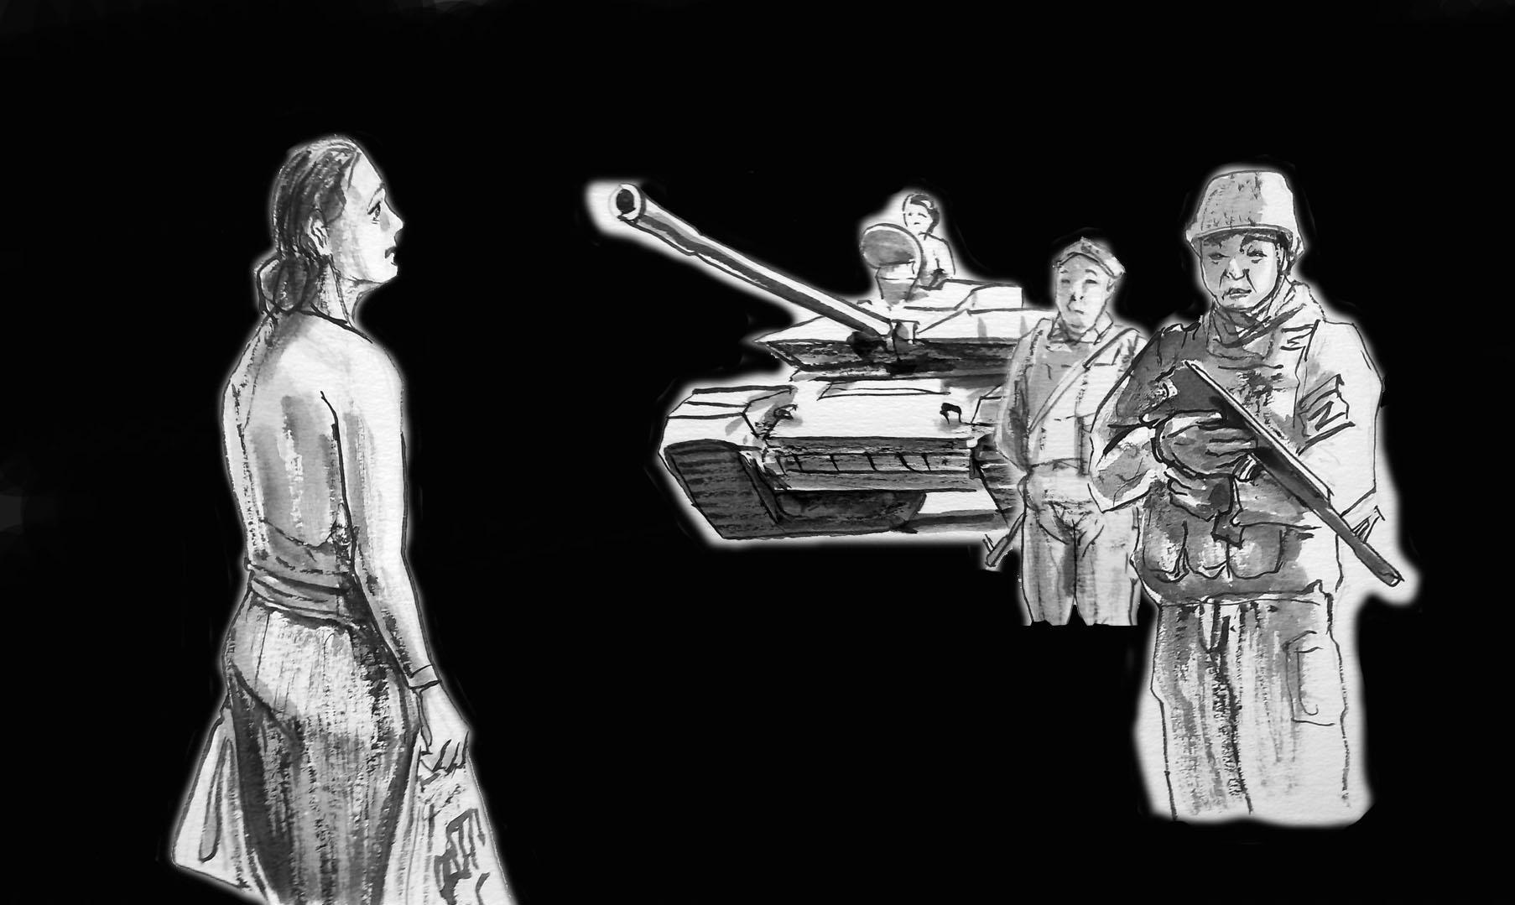

Fig. 2: “I was standing there with my bags, looking at them… They were staring at me…” (artist: Serhiy Zakharov)

W26(55+): “I went shopping. The street was empty. I entered the store and started shopping. I heard loud noises… They started banging on the door… And then they left… I waited. All was quiet… So I took my bags and went out… One tank was blocking the road, and another was standing on the pavement in front of our entrance gate… They had machine guns… Buryats… It was impossible to escape… I was standing there with my bags, looking at them… They were staring at me… I wanted to pass the tank, but one of them waved at me, ‘Don’t!’ He was watching my every step…”

One of the witnesses was held hostage in her own private home. On orders from the armed representatives of the Russian occupying forces, the witness cooked their meals and cleaned for the invaders.

W26(55+): “At first they would come and behave as if they owned the place… Once they ordered me to cook a meal for them. They always had their weapons at hand… He opened the freezer and said, ‘You don’t want us to take food from your neighbors, do you?’ I said I didn’t. (…) ‘You have some food, cook us a meal.’ (…) ‘And if I won’t?’ ‘Well…’ and he brandished his weapon [machine gun – ed.] (…) Some come, some go away… And you are a nobody, a temporary person.”

The alleged commander of one of the units stationed in the area pre-selected a local woman as his victim. The persecutor demanded the victims’ constant presence and threatened to kill her husband if she disobeyed him.

W26(55+): “(…) And then they brought that tank soldier (…). I think that they brought him on purpose, that they had it planned. He behaved like an insane person… Or as if he were on pills… He was very strange, he came to me and said: ‘Those black tights, those yellow bags…’ I realized that he had been in that tank [he remembered what she had looked like – ed.]. He was messed up… He got himself worked up about it. ‘You’ll make a good deal’, he said. I asked him how old he was. He replied that he was 32. I told him that my son was 35 years old and that I was not a pervert. (…) ‘Although I will kill you anyway, I cannot leave any witnesses behind…’ He wanted to shoot me…”

The occupiers fully controlled all of the witness’ movements, threatening and intimidating her when she went out to the yard or gave food to her neighbor in the house next door.

W26(55+): “(…) ‘Remember, if you don’t come back, we will have to shoot your husband.’ This was supposed to prevent me from running away. He was exerting psychological pressure. He went outside, dragging me with him to the garage… They had some sort of a fight there… I experienced high blood pressure and nausea… I fainted… I ran back home to my dressing room and bolted the door. I wasn’t going to give up… He entered and knocked on the door: ‘Why are you so afraid, I won’t hurt you.’ And again: ‘Let’s go, let’s go…’ Then he fell down. I went out to the corridor. I locked myself in. I couldn’t sleep until morning, I kept listening in the dark.”

The witness could not escape, because she was aware of a direct threat to her life and the life of her husband. The threats were uttered by a member of the Russian occupation army.

W26(55+): “A gray-haired Buryat came… He sat down on the stairs and said, ‘Why didn’t you leave? You [as a woman – ed.] should have been the first to leave. Leave!’ And then I remembered that my husband would be shot… I hid myself in the corner…”

The persecution of witnesses by the Russian troops posed a threat also to the lives of other residents.

W26(55+): “I heard a shot at my neighbor’s house… (…) ‘I almost shot a grandma because of you.’ He broke her door down. He was searching… He spent the whole day there. I was feeding a grandma – my neighbor. I stayed with her for an hour and a half or so… And then he came running… I jumped up… (…) ‘Where are you?!’ (…) They stayed there for a whole day… At about noon he was already drunk. (…) He wasn’t bothering me. He was just sitting there with his machine gun, watching me, so that I would not get away. He was somehow changed (…) He was drinking vodka…”

According to the witnesses, in the Russian-occupied territories even favorable attitudes towards the occupying army and collaboration with Russia did not guarantee safety to women.

W54(45+) [male – ed.]: “(…) A resident of the neighboring village. She openly declared her pro-Russian stance. (…) She approached a vehicle with military men inside. It was in the city of Berdyansk, close to our military recruitment center. She waved her Ukrainian passport and asked for a Russian one. A few days later I learned that this girl was found in the outskirts of the village; she was raped and murdered by the Russian troops.”

4. Circumstances surrounding the committing of crimes by Russian occupying forces.

At the witness’ home

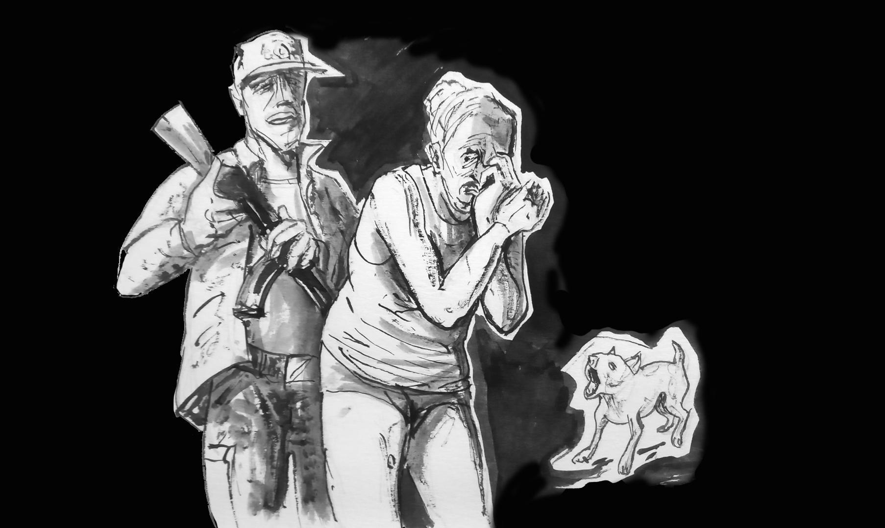

Fig. 3: “He aimed his pistol at me, ripped off my shirt and underwear and took me outside… He hit me with his machine gun, sometimes in the buttocks, sometimes in the chest…” (artist: Serhiy Zakharov)

W20(55+): “(…) He said, ‘Let’s go inside!’ He closed the door. He also examined me. ‘Take your clothes off quickly!’ It was 5 degrees at home. I started to undress slowly… I said, ‘Maybe I don’t have to?’ I started to cry… (…) ‘I’m an old woman, what do you need me for?’
He aimed his gun at me. I was wearing only my undershirt and underwear. He aimed his machine gun at me, ripped of my shirt and underwear and took me outside… He hit me with his machine gun, sometimes in the buttocks, sometimes in the chest… I could see he was enjoying it. I fell to my knees… He hit me and hit me… (…) ‘Get back in the house!’ Then he took me around the house, through the yard and inside… the sofa was set up there…”

W23(75+): “When the soldiers left [Russian soldiers who were living illegally in the witness’ home – ed.] a sedan car pulled up in the evening. ‘Where are the lads who live here?’ I replied, ‘They are looking for another house’. I blame myself. Why did I stay at home? (...) Around 11:30 at night I went and lay down in the kitchen. It was cold and damp in the basement, even though it was July… I just fell asleep. Then a terrible knocking sounded on the veranda.... Goosebumps went up all over my body – I was so scared.... One window was slightly ajar. I looked through the window; there was a soldier with an assault rifle, in the middle of the night...”

W26(55+): “He [a member of the Russian occupying forces who had been harassing the witness for several days – ed.] arrived on a bicycle at around dinner time. He knelt down and started to kiss my hand. He was checking if we were there. He was just checking. Then we were attacked at night…”
Elsewhere

In some cases, representatives of the Russian occupying forces took the victims to abandoned civilian homes or to where their units were located.

W21(55+): “Then they came and took me to the staff headquarters…”

W24(35+): “(…) ‘Just imagine, Oleg, who we’re going to fuck! One is 41 years old, the other 43…’ They took my neighbor upstairs, and I was downstairs…
I had not been in that house before the war, but they already knew everything… (…)
‘Either I rape you here, or we go out to the tank and the whole company will rape you.’ (…) I said, ‘Rape me here…’

W44(75+): “(…) I saw my daughter. He was leading her… And she was screaming, ‘Where is my husband?!!!’ (…) ‘They took my husband… let’s go!’ (…) She yelled, ‘let’s go!’ (…) ‘Where are you taking her? Why?’ But he just waved his hand at me, ‘Get back!’ Don’t scream, don’t scream – who is going to help you?”

W27(45+): “Soldiers came to my office. There were 7 of them. They searched through my computer and my desk (…) Then they led me out (…) and put a bag over my head in the corridor (…). They twisted my arms, bent me forwards and took me somewhere… They dragged me into a room called the electrical substation. It was on the basement level. They took the bag off my head.”

W25(25+): “(…) He put a hat over my eyes and drove for 2 minutes. He opened the door to the house. He led me upstairs and showed me the bed…”

The Russian army and militants in the Russian-controlled unrecognized republics in the occupied territories of Ukraine set up a system of filtration camps and offices where local civilians are checked for loyalty to the occupying authorities. This is particularly the case for people who wish to travel to Ukrainian-controlled territories on their own or via humanitarian corridors. According to witnesses, Russian military officers have used the filtration centers to harass women and search for potential victims.

W66(18+): “The filtration center is a small room with three tables and three Russian soldiers. You go in there one by one, they take pictures of your face, and prints from your fingers and your whole hand. They asked why we were being filtered, why we were leaving. There was no permission to leave without first being filtered. The military asked why such a beautiful girl was not going out for a walk. ‘We’ve never seen you before,’ they said. I replied that I didn’t like going out and preferred staying at home. They took my passport, looked at my place of residence and said, ‘Alright. We’ll come by. We know where it is.’ From then on being in the house was very scary. We kept the windows and doors locked 24/7.”

Women were also subjected to various forms of sexual violence at checkpoints between temporarily occupied territories and those controlled by the Ukrainian forces, where representatives of the Russian occupying forces took the opportunity to pick out their victims.

W52(35+): “For several days, the Russian military delayed the queues of passenger cars that wanted to leave the occupied territory into Ukrainian-controlled territory. This is just my opinion, but they were happy with the situation, they liked it. And the more beautiful the woman was, the longer she was harassed, the more questions they asked her, the more they mocked her... We were very careful about the people who came [to the collection point for refugees from the occupied territories – ed.] For example, one woman was looking very carefully at the knives in the office, and there was such madness in her eyes... We followed her and she ran to the corner and told us that she had been forced to give a blowjob to a Russian soldier in front of her father, son and husband. He was a Buryat. She said it was at one of the checkpoints where they were waiting in their car to be evacuated.”

W52(35+): “Men were checked for tattoos at the checkpoints and women were forced to undress and made to dance... They made them squat, bend down, touch them.... It was very disgusting for the women.... The Russian military did not respect women and will never respect them…”

W46(35+): “(...) A Dagestani man approached (...). He started looking through my phone and found a photo from 7 years ago. My brother, a first-year student at the Academy, in uniform. He [the Dagestani man – ed.] asked, ‘Who is that? An AFU soldier?’ I was so scared... He said, ‘You are about to get off, have your brother come and take you…’ I realized that there were children sitting behind me and the possibility that I would be taken away was very likely. I don’t know if it’s better for it to happen here... Whether to let them take me away, torture me and whatever else; I understand what they will do to me... [The witness refers to sexual violence – ed.]”

The witness describes what happened to her friend.

W16(55+): “(...) She was riding a bus and talking to her brother. It was on 12 November [2022 – ed.] and apparently her brother told her that Kherson had been liberated, that it was in Ukrainian hands, and she said on the phone, ‘Thank God Kherson is ours’. A couple sitting behind her reported her at a checkpoint. [The woman was then illegally arrested at the checkpoint by the Russian military – ed.]”

5. Rape and CRSV committed by members of the occupying army.

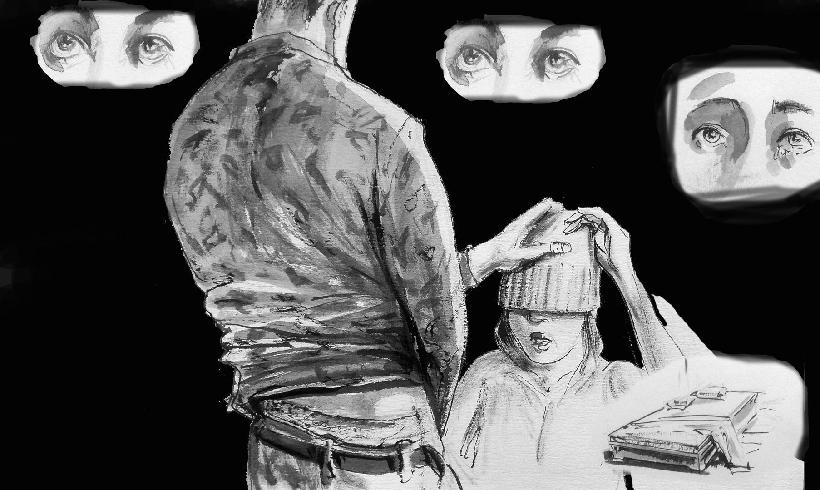

Fig. 4: “(...) I had only a hat over my eyes; I took it off. He told me not to take it off because ‘I can’t look you in the eyes’.” (artist: Serhiy Zakharov)

W25(25+): “(...)
‘I’m not interested in your phone…’
‘Will it be just you?’
‘Do you want a lot of us? I have a queue waiting for you…’
‘Just you.’
He squeezed me hard, choked me, grabbed me... At first he did it calmly, then he got angry. I had a hat over my eyes and I wanted to take it off. He told me not to take it off because ‘I can’t look you in the eyes…’, and I said, ‘Look me in the eyes’. He started to get angry. In terms of my mental state, I can say that I just understood what was going to happen. I didn’t resist, I just wanted it to be over as soon as possible. But I didn’t want to be a victim. That’s why I was so... My eyes…”

W24(35+) “He said to me, ‘You’re hurting me’. He grabbed my skin, put me on the couch and started raping me... (...) ‘Aren’t you going to kill me?’ I was scared... Then he made me do very bad things... He was very unruly... At gunpoint.... Suck, latch on like a crayfish. He took my trousers off, then raped me, then made me suck again…”

W20(55+): “In one hand he held a machine gun. I was crying, screaming... I could not oppose him in any way. (...) ‘Be quiet or it will get worse!’ He started beating me with the machine gun, then with his hands.... He didn’t undress, he just unzipped. A little dog was running around, running up to me... And he started to rape me... (...) He finished inside me and on the rug. I left it as evidence of the crime. Then I threw it away.”

Gang rape

W21(55+): “What can I say? He raped me… I think there were two others… (...) A colonel from the FSB came. He told me to take everything off, apologized and told me to go home.”

W51(70+) [male – ed.]: “How did they rape? They came to my neighbor, put the barrel of a rifle in her mouth and led her behind the building… It was at night; in the morning she came running to me and asked, ‘What should I do?’”

W50(65+): “(...) [The Russian soldiers – ed.] were drunk (...). There were four men (...). They knocked on the door. My mother opened, four of them pushed their way in and they wanted to rape the girl. She was younger than 18. She screamed, fought, protected her daughter, but she couldn’t. There were four of them with machine guns. They beat her with the butts of their weapons. First they raped her daughter; she was just a girl, a virgin. Then they raped the mother. They mocked her. They said that if she told anyone, they would come at night and stab her.”

W26(55+): “Around 2 a.m.... There was such a noise on the second floor. They came in through the window... The husband ran to open the door – a machine gun.... (...) ‘Three steps back! Three more! Three more!’ And there was a wall... A shot... He took a flashlight. He took me to the garage. They strangled me. They had little hands. One clamped my mouth shut, the other held my nose… With a gun digging into my breasts. I didn’t think about saying yes. But then I thought about my son. That only he would survive. So at least there was a chance... Well...
And as soon as I said yes, they immediately started [raping - ed.], one ‘from below’, the other ‘from above’... Then they beat me, pushed me... Then they dragged me into the house, left me there and went away…”

W27(45+): “They were aggressive… They undressed me themselves. It was gang rape… (...) They attacked me like animals.”

W22(45+): “(...) And he led me with the barrel [of a rifle – ed.] in my back (...). He took me to the house next door. It was locked. He took me to the next one.
He gave an order. With a knife, and a machine gun… Their intelligence came in. They came in and stopped everything. They told me to get dressed and took me home.”

6. Threats against the victims and their families by representatives of the Russian occupying forces.

Sometimes Russian military officers threatened victims with the murder of family members if they tried to leave the temporarily occupied territories or spread information about the crime. Threats to kill family members sometimes occurred during rapes.

In one case, after the murder of the victim’s husband, a representative of the Russian occupation army threatened to kill the victim’s son.

W44(75+): “My daughter said that he manipulated her son. He said, ‘Do you want your son to…’ [referring to a threat against the victim’s son – ed.]”

W45(65+): “He kept torturing me, and then the phone rang (...). He said, ‘Consider yourself lucky, but if you tell anyone, I’ll drag you to the basement and bury you so deep no dog will ever find you. And if you tell any of the neighbors, I’ll come back with a gun and shoot everyone. The neighbors and you…’.”

W55(45+): “(...) She went to complain to the staff [of the Russian army unit stationed in the village where the witness lived – ed.], and she was told that if she told anyone, they would come and shoot the whole family…”

W27(45+): “They [Russian military – ed.] wanted me to somehow get her [the victim’s sister – ed.] to Donetsk. They tried to find out if I was associated with the Ukrainian army.”

W22(45+): “He didn’t even speak... He showed me with his machine gun what to do. (...) He locked up my husband. And he told me to get dressed and go into captivity.”

W25(25+): “(...) [Russian military – ed.], ‘Get ready, we’re going for an interrogation.’ My father asked me... I understood I had to go because my family would get into trouble... I told them [my family – ed.] I’d be back. The next day he came again... He made up a reason for me to translate from Ukrainian to Russian. I knew I had to leave again because my father would attack him... Gritting my teeth, I went again... It was clear what was there... He left his subordinates with my parents, saying they were psychologists... I came back. Father was worried, he said, ‘I’m dying…’.”

In some cases, Russian soldiers would take the relatives of victims for forced labor to deprive the victim of protection.

W26(55+): “Then one evening they brought me this tanker (...). And he said, ‘Wait, ladies, you’re not going anywhere until your husband comes.’
‘Where is he?’
‘He went to work digging trenches for us... I’ll strangle you!’
He immediately pulled out a gun...
‘I’d like to [dig trenches too – ed.]... But I left on a business trip for 8.5 months, I came back, and there’s a stranger in my house tidying up like he owns the place…”

In some cases, victims were still persecuted after being exploited, making it difficult to escape from the temporarily occupied territories. One victim changed and hid her place of residence several times, waiting for an opportunity to leave for territories controlled by Ukraine.

W26(55+): “For 3 days we were fed by neighbors (...). One day a neighbor rushed in, ‘Quick, take your things! I found you another home…’. She came to say that [the Russian army – ed.] already knew where we were... We moved, and within a few hours, they attacked [the neighbors – ed.] They didn’t say anything. They were looking for that bitch... They got beaten because of us. They didn’t sell us out. And in the [other – ed.] house, girls brought us food. And then they pretended they hadn’t seen us for five days.
As soon as we left where we were living, a trap [set by the Russian occupying forces – ed.] was waiting for us.”

7. Killings of victims or family members of witnesses by representatives of the Russian occupying forces.

Witnesses interviewed by the Raphael Lemkin Center for Documenting Russian Crimes in Ukraine suffered not only from sexual and psychological violence, but their family members were also tortured or in some cases killed.

Testimonies include situations in which representatives of the Russian occupying forces deprived victims of possible protection by deliberately killing male family members.

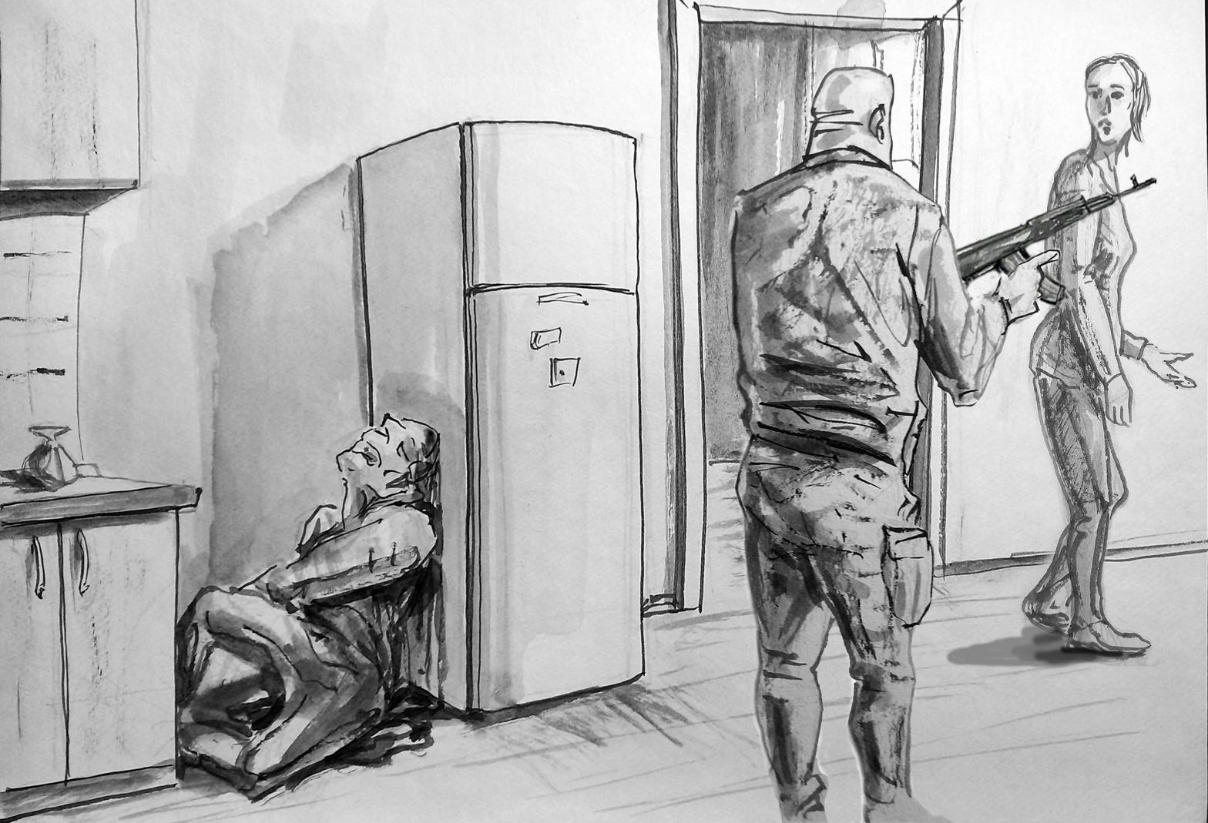

Fig. 5: “(...) My son-in-law was lying, his head resting against the fridge (...).” (artist: Serhiy Zakharov)

A witness at the Center for Documenting Russian Crimes in Ukraine recounted how the occupiers entered her home and killed her son-in-law. She only learned of her son-in-law’s death after the occupiers left the house and forcibly took her daughter away for sexual violence.

W24(35+)C: “(...) [the neighbor’s husband – ed.] opened the door at once:
‘Give me your woman…’ [said the Russian soldier – ed.]
‘I am Russian…’ [the neighbor’s husband replied, citing his ethnic origin – ed.]
And then he [the Russian soldier – ed.] fired a shot... I didn’t see where it hit. I stood there trembling all over…”

W44(75+): “I heard a sort of ‘click.’ My heart skipped a beat. And then I heard silence, something quiet... (...) There was something in the house... I looked – blood... I threw down some rags... Then I looked over – there lay my son-in-law... He [the Russian soldier – ed.] put him there... And he positioned his legs like this, his head by the fridge... I adjusted his legs, thinking I’d now adjust his head. I took his head like this, and everything was already soft... He was still alive... And something was knocking around in his head, like he had the hiccups. I thought I could treat him. But I saw he had stopped [breathing – ed.]... I covered his eyes... We buried my son-in-law’s body in the garden…”

W24(35+): “(...) Around half past ten, there was a knock on the door (...). I opened it; I thought it might be a neighbor... I opened the door, and there were three occupiers standing there. They said, ‘You’re coming with us, and your husband is going to the headquarters.’ They took me outside. They groped me... I said, ‘Get your hands off me!’ He said, ‘Shut up!’ (...) ‘Understand, our boys have been drinking and want to have some fun…’
I hear a gunshot in the house:
‘Did they kill my husband?’
‘No, they shouldn’t have.’
‘Where is my husband?’
‘There. He’s by the wardrobe…’
‘You’re not going to kill us?’
‘No.’
There was a sound like he shot into the ground. A dull sound, like a firecracker exploding.”

One victim’s husband was not able to oppose when his wife was detained by representatives of the Russian occupying army and followed them.

W22(45+): “My husband just followed us... No weapon, nothing. He was hit by a burst from an automatic weapon. My husband reached the neighbors’ house and collapsed on the doorstep...”

W37(45+), [male – ed.]: “There was a case that definitely crossed all boundaries. On 18 November, around 8:00 p.m., a group of Russian invaders passed through the village, knocking on people’s doors and demanding alcohol. About the fourth house they came to belonged to a family with a wife, a husband, and two children aged 4 and 13. (...) In the morning, we found the husband shot in the middle of the yard, the wife on the ground floor with signs of violent death, and the two children on the second floor shot in the head. It was such cruelty... (…) The body bore signs of rape... According to the local residents, the woman had been raped.”

8. Cases of rape of minors and the elderly committed by representatives of the Russian occupying forces.

In testimonies collected by the Raphael Lemkin Center for Documenting Russian Crimes in Ukraine, victims also described their fear of the rape of minors.

W29(45+): “(...) I was very afraid for my daughter because she was only 13, you know… She’s a very pretty girl. I even hid here behind all our things, behind everything, so… I held her hand, she sat between us in the basement…”

W29(45+): “We used to hide our daughter under the bed, but I understand that it wouldn’t have helped very much…”

W27(45+): “I was so afraid for my daughter… she was 17 years old.”

Victims testified about cases in which armed Russian soldiers deliberately persecuted young girls who were alone at home during the occupation.

W53(55+): “My daughter’s computer was stolen, taken by those separatists… And they laughed, read he private messages, saying, ‘Did you read about her first kiss?’”

W56(M): “He [a member of the Russian occupying forces during a search – ed.] stood there looking at me… I was afraid, he walked towards me, he… He had such a piercing look in his eyes as if he wanted to take me and… rape me.”

W57(18+): “They were acting like, ‘Let’s get to know each other…’, ‘I want to talk to you…’, ‘Let’s eat something, let’s drink some tea…’. I always answered, ‘No!’ I didn’t have time, I always locked the doors, and they always came out. I even closed the doors in the house, as if I wasn’t there at all… They hung around by the fence, calling for me.”

W57(18+): “There was one situation – it was unpleasant. He [the Russian soldier – ed.] first came and tried to take my phone number. I don’t give out my number. That was it – goodbye! And then, after some time, he [the Russian soldier – ed.] came to me... I was in the yard, I tried to quickly close the door.... And he broke down the door, began to approach me, ‘Let’s talk, I want to talk to you…’. I said, ‘I’m not going to talk to you, I’m busy. Please leave me alone.’ And he said, ‘No. What’s the matter? Let’s talk…’. He stood at the front door. I said, ‘I’m not going to talk to you. I have nothing to talk to you about…’. He entered the house, turned on the light and said, ‘I’m going to stand here until you come to me.’ I said, ‘Well, stand there…’. I walked away, texted a friend to get someone to come help me. And he started to follow me, I ran away from him. He grabbed my arm and pushed me against the wall. I said, ‘Don’t touch me, let me go!’ I tried to push back... He did not let go... I said, ‘You’re hurting me.’ I wrenched myself free, ran to the gate, to the neighbors, and he followed me... I was very frightened, I was almost crying... Thank God my friend came. She chased him away and it was over. I ran into the house and started crying. Actually I was a little afraid, because there was a man standing there... Well, he had a gun, a machine gun, and he was stronger than me anyway... How could I fight him off if he had a gun in his hands?”

W55(45+): “A neighbor’s son was taken from the street and shot. Then her 17-year-old daughter was taken away... She ran after her daughter... The neighbor said she was beaten with rifle butts because she tried to protect her daughter from being raped. That there were four people who raped her daughter, and then she herself was also raped…”

The Raphael Lemkin Center for Documenting Russian Crimes in Ukraine recorded a case of sexual violence against a minor by collaborators working with the occupying army.

W43(55+): “He rode with them on APCs, fraternized with the Russians. He believed they considered him one of their own. They plied him with vodka, he made merry with them. They let him do everything... This led him to impunity. He boasted that he knew all the Russian commanders. He was not afraid of anyone. There was no protection, no government to protect civilians, it was total lawlessness... They did what they wanted... Everybody just did what they wanted... They felt impunity...”

According to the Criminal Code of Ukraine, sexual violence against minors is punishable by 7 to 12 years in prison, while the Criminal Code of the Russian Federation provides for 3 to 10 years in prison or forced labor. However, in the temporarily occupied territories, representatives of the Russian army and collaborating Ukrainian citizens do not obey the laws of any of the countries involved in the armed conflict, feeling complete impunity.

W43(55+): “When he started raping her, she was 12 years old. There were six women in the village who he set up with Russians. He was their pimp. He could do whatever he wanted with them... Why did he need the child... When the Russian servicemen wanted a woman, they called him and he arranged everything for them. In the same house where he raped my daughter. He abused my daughter throughout the occupation... He raped her in the empty house of a neighbor who had moved out... She told me that he dragged her into the house, hit her and took her by force. He weighed 100 kilograms, and she weighed 40 kilograms. What could she do?”

Given that the witness’ older sons were serving in the Ukrainian army at the time, the witness and her three minor children were placed in circumstances of imminent danger to their lives by representatives of the Russian occupying army, which allowed collaborators to manipulate and exert psychological pressure not only on the witness, but also threaten the life and health of the victim’s family.

W43(55+): “I have two sons who are in the army. The collaborators told me: ‘Be afraid! If we tell the Russians about your sons, they will deport you and no one will find you…’ I was so frightened that my legs gave in, I couldn’t walk…”.
My daughter didn’t say anything because he threatened her, ‘If you tell your mother, I will smother her with a pillow, and I will slash her brothers with knives…’. She remained silent the whole time... She walked around smiling... I don’t understand how you can hide such emotions like that. That’s why my daughter didn’t say anything until her belly started to grow.”

W43(55+): “At first I panicked and wanted to have an abortion. The doctors said that if I had come a week earlier, they would have done it, but it was too late... We decided to give birth because there was no other choice... Later, in Kyiv [after seizing the territory where the victim had been living – ed.], they gave her a C-section. The fetus was large, she would not have given birth on her own…”

According to Ukrainian law, the mother must raise the child until the victim reaches the age of majority. After experiencing violence, the victim did not want to see the newborn, and her mother decided to abandon the baby in the maternity hospital.

W43(55+): “(...) We left the baby in the delivery room. I just couldn’t look at that baby. I saw that baby, it was crying, and I cried over it for probably an hour... I understand that my... Well, God forgive me, but I couldn’t do it... We gave up the child... My daughter is just a regular teenager. To give her a child now would ruin her life... Honestly, if it had been apparent that my daughter wanted this child, maybe I would have taken it, but from the first days the child was a stranger to her... She didn't even want to see it... She told me, ‘You need it, then you take it.’ I said to her, ‘This is your baby.’ She replied, ‘I don’t have a child…’.

The threat of sexual violence by representatives of the Russian occupying army also affected elderly women.
In most cases, such crimes lead directly to the death of the victim.

W5(M): “An 80-year-old woman was raped by four Russian soldiers and died…”.

W40(55+): “Well, to rape an 82-year-old woman... Poor thing, with pills in her hands and she died… It’s terrible!”

As witnesses recall, representatives of the Russian occupying forces behaved aggressively when committing crimes against women: they inflicted injuries on them, threatened or beat them with weapons, cut them with knives, knocked out their teeth, mutilated them, regardless of the age or behavior of the victim.

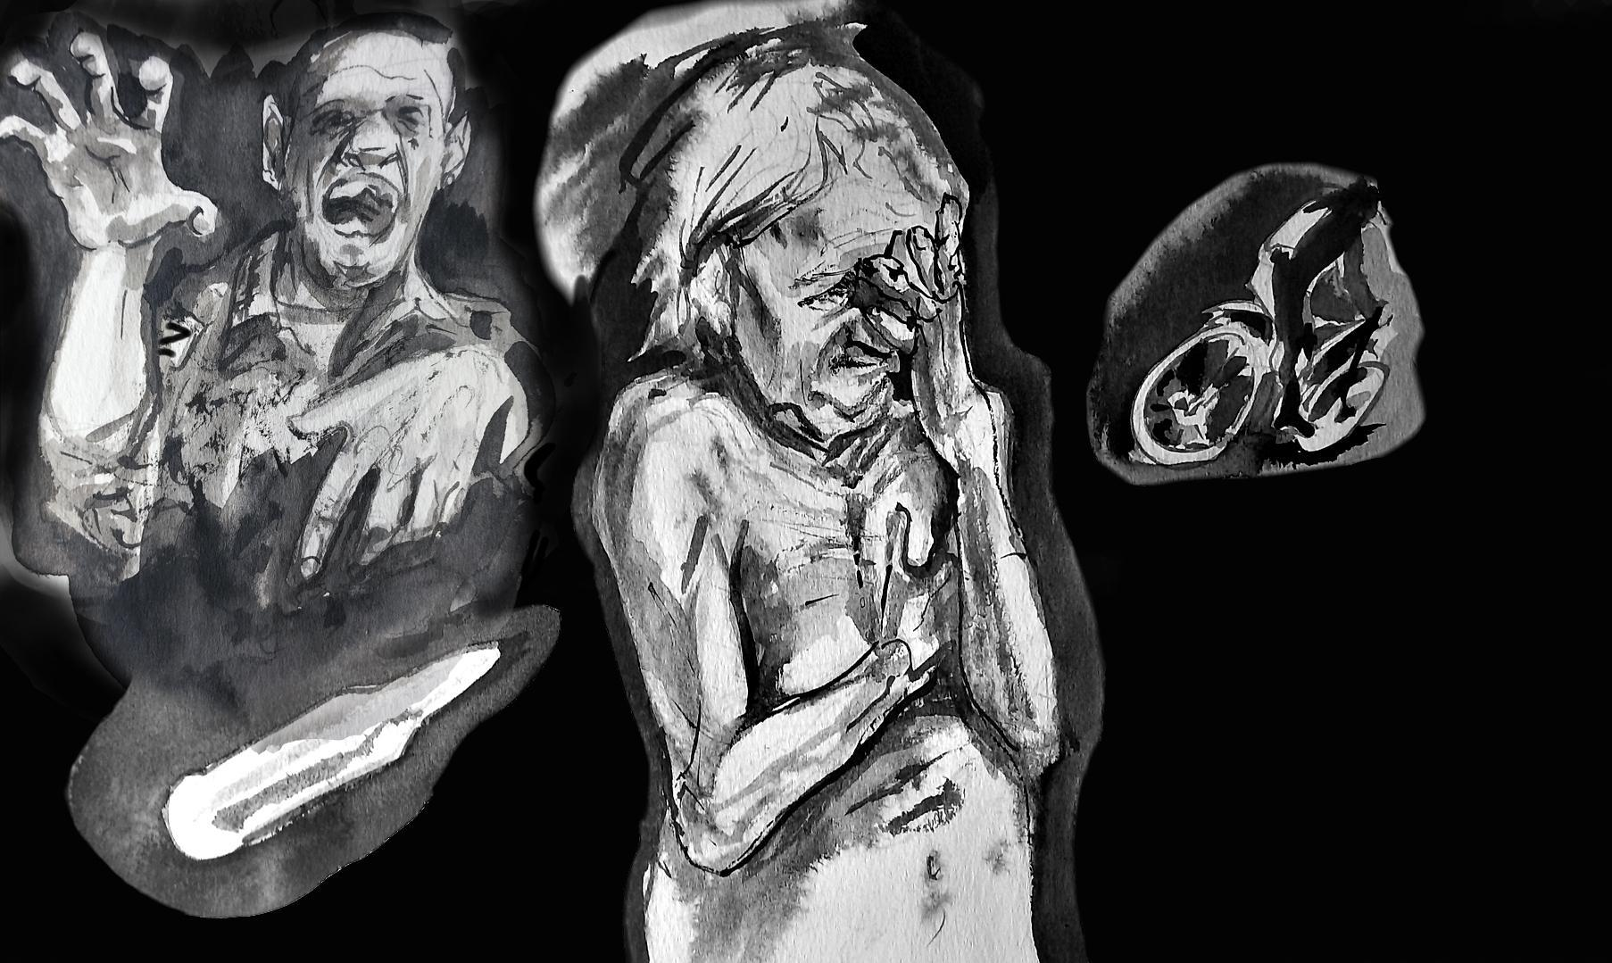

Fig. 6: “(...) ‘Just try and tell someone! I’ll come one day soon and I’ll kill you. I’ll kill you with this bullet!’ And he threw me the bullet…” (artist: Serhiy Zakharov)

W23(75+): “I decided to open [the door – ed.] And then he hit me in the face with a rifle butt... My teeth were knocked out... He grabbed me by the hair... (...) And he dragged me around the kitchen. I was crying, screaming... (...) ‘Don’t cry, shut up!’ It was a nightmare... He was beating me with his rifle, beating me... He threw me on the sofa and started choking me... He tore at me, choked me... I didn’t even feel any pain. He stabbed me twice in the abdomen... I still have a scar where he cut deep… He started pulling my clothes off me... I struggled as much as I could... He also started questioning me...
(...)
‘Who was here?’ [asking about the Russian servicemen who had earlier tried to occupy the witness’s house – ed.]
‘I don’t know.’
‘What color was the car? (...) Don’t you know?’ A blow to the head, with the rifle butt...
(...)
‘What brand of car?’
‘I don’t know anything about car brands (...)’. Another blow (...).
‘What were their names?’
‘Yura, Lyosha and I forget... I don’t even know those two…’
(...) Another blow...
(...)
‘I’ll write it down…’
He picked up a touchscreen phone. He pretended to write it down... I saw the dark screen. He came at half past ten, beat me for an hour, taunted me...
(...) ‘How many men are in the village?’ I said, ‘I don't know!’”

W23(75+): “And then he started to rip off my clothes, he started to rape me... And then he started putting it in my mouth. ‘Suck it! Suck it!’ I was blue, my face was blue, my lips were cut... I had no way out... He fell asleep. I lay naked next to him, afraid to move... I thought that if I moved away, he would shoot me... (...) It was getting light and I said, ‘You have to go now’ (...). ‘Yes, now…’. He started raping me again... Then he started to get dressed... He put on a shirt. He started looking for his cap, but couldn’t find it... (...) ‘Look for my cap!’ I said, ‘Give me your phone, I’ll use the flashlight and find it.’ He went out on the veranda and hid so I wouldn’t recognize him. (...) ‘Don’t say a word! I’ll come one day soon and I'll kill you, I’ll kill you with this bullet!’ And he threw me a bullet... About half an hour later, I came out and saw that my bike, which had been standing by the fence, was gone. The gate was open. He left... [The Russian soldier rode away on the victim’s bicycle after the rape – ed.]”

W45(65+): “Something shone in my eyes... I woke up and sat on the couch, and there he was [the Russian soldier – ed.]. I couldn’t see his face. I said, ‘Who are you and what do you want?’ It was so frightening... He was silent, and then he said, ‘Did you have any visitors?’ I asked, ‘What visitors?’ He repeated the same question like a parrot: ‘Did you have visitors? Answer! Are you going to talk, or should I take you to school?’ [the Russian occupiers set up a torture chamber for civilians in the local school – ed.]. ‘Undress!’ I replied, ‘You are my son’s age! What if someone did this to your mother?’ And he immediately hit me with the butt of his rifle. My lip swelled up and began to bleed... It was so horrifying that I am ashamed to even talk about it... He unzipped his pants... He started shoving it into my mouth, I almost choked... He did it all... Then he turned me around and started raping me wherever he could…”

W47(55+): “(...) His name was Bulat, he said he was a medical captain. He walked around all day drunk, sat on the table, took everything I had there and ate... Then he said to me: ‘Oh, you’re not so bad, and I miss my wife very much, see how beautiful she is. Her name is Zinka.’ And indeed, he showed me a Buryat woman in a red dress.... (...) ‘And, hey, you’re still so juicy, let’s go upstairs…’. I asked him, ‘How old are you?’ He replied, ‘32’. And I said, ‘And I’m 62 ... I’m an old woman’ (...). ‘No, no, you’re not old, come on…’. He lifted his shirt, then lifted his undershirt: ‘Feel how my heart beats…’. I said, ‘You have no heart.’ I thought, I have to go through all this horror somehow... He started pulling me upstairs. I remembered that I had a jar of wine on the veranda that was old and had gone bad – maybe it would be my one salvation... I suggested: ‘Let’s have a drink! What’s love without a little drink?’ I ran for the jar and poured him the whole glass. He drank it right away. I watched for about three or four minutes, and his legs began to falter, and then he began to drool, his head drooped… I poured him another glass and, of course, poured for myself as well... I didn’t drink, I just pretended... He drank a second glass, but did not abandon his plan. ‘Let's go, now!’ and he was so drunk…”

W18(65+): “(...) This Moskal dragged me somewhere... I don’t know what he wanted from me... He was about 50 years old, had a scar on his face... We were standing at the gate, he walked past, and then came back to us, took me like this by the hand and cursed, ‘You, bitch, you must have been beautiful in your youth?’ and I said: ‘God, when was then? I don’t even remember my youth anymore.’ My legs were already shaking and I said to my neighbor, ‘Let’s go inside, I can’t stand anymore…’ And he said. ‘Are you sick?’ I replied, ‘Yes, I am – very sick’. (...) ‘What’s the matter?’ And I said, ‘Oh, I don’t know... The doctors said it’s some kind of gonorrhea, but I don’t know what it is…’ That was the first thing that came to mind out of horror. Then he took a rifle and pointed it at me: ‘Then you should be shot, bitch!’ And I said, ‘My God, little dove, don't stain your soul with sin. How much time do I have left… I will die soon anyway. I’m not going to pass away, I’m going to die’.”

9. Illegal detentions, torture, and sexual crimes committed by representatives of the Russian army.

In the temporarily occupied territories of Ukraine, Russia has established a network of torture chambers and prisons, detention centers, penal colonies, as well as hidden places of detention, such as basements.

Each of the testimonies collected by the Raphael Lemkin Center for Documenting Russian Crimes in Ukraine falls under the article of the Rome Statute concerning crimes against humanity, namely cruel deprivation of liberty, torture, rape, and sexual slavery. All of this has led to serious mental and physical harm to the witnesses.

Due to the anonymity and safety of the witnesses, the Raphael Lemkin Center for Documenting Russian Crimes in Ukraine uses the terms “they” and “he” in the context of employees of the Russian Federation’s special services, members of so-called “law enforcement agencies” controlled by Russia, representatives of the Russian occupying army, and illegal armed groups controlling the temporarily occupied territories of the Donetsk and Luhansk regions.

9.1 Circumstances of the illegal detention of Ukrainian women

Witnesses were illegally detained by agents of the Russian special services and the Russian military, representatives of illegal armed groups and so-called “law enforcement agencies” in the temporarily occupied territories. Most of the witnesses were taken from their homes, generally in the evening hours.

W15(45+): “Sometime after 10 p.m., after we had finished dinner, I heard knocking on the door. I looked through the peephole, but it was closed, I couldn’t see anything, it was dark... Immediately I understood that they had come to us – the Russian Federation...”

W9(55+): “(...) I approached the window and heard a car approaching. Two cars stopped... I saw armed men in military uniforms... They were heading towards our gate...”

W53(55+): “(...) They began to climb over the fence (...). They opened the gate and immediately started hitting me with rifle butts. They pulled a hat over my head so I couldn’t see anything. Immediately they put handcuffs on my hands. They said I was an American spy.”

W63(45+): “(...) And immediately they started shooting into the air and at my feet. They said, ‘Bitch, we’ll shoot your knees, dress quickly!’ I understand they were Russian soldiers. They used Russian slang.”

W28(45+): “It was a kidnapping. Against my will and in such a brazen way... They scared me a lot. Three people entered our house, they were armed, but not in military uniforms... I realized it was the FSB...”

W41(45+): “It was the FSB; the cars were civilian, not military. They were dressed in black uniforms with no markings, nothing. They wore masks, had weapons, but they weren’t military... I looked at their hands holding the weapons, they weren’t military. They had clean, white hands...”

W63(45+): “I said, ‘I have my elderly mother in the room, please don’t shoot.’ And they said, ‘Yeah, we need that bitch too...’ and they grabbed her from the bed and started pushing her...”

W9(55+): “(...) It was very scary, eight armed men at night. ‘Open the door – we’re here for you!’ I tried to remain as calm as possible and started saying, ‘How can I open the door to armed men at night, please tell me, what have you come for?’ (...) ‘Don’t be afraid, there’s nothing to fear with us, open the door. We’ve come to protect you!’ I was very scared, but I tried to remain calm.”

W63(45+): “(...) They pushed me into the corridor, shoved the dog out the door. They shouted and cursed... (...) ‘Come on, hurry up, get dressed!’ Every now and then they shot into the air and at my feet. Three times I hid the dog, and then I heard shots, and a soldier enters with bloodied boots... The dog has just been shot...”

W28(45+): “(...) they told me to get dressed, I was only in a robe at the time. They followed me to the second floor. I asked them to leave me alone, and they said, ‘No, you’re going to change in front of us!’ That means they told me to undress and dress, and they watched. They didn’t even turn away. There were two men standing next to me. Literally three meters away from me. I felt like they were undressing me and I was afraid they might harm me or rape me...”

W63(45+): “(...) They put a bag over my head, some sort of rag, and tied my head with tape, and my hands behind my back. One of them pushed me so hard that the robe fell off and I was left naked, alone in the middle of the house, among 10 strange, hostile men...”

W53(55+): “(...) They put me in the car. My eyes were covered with a cap. The handcuffs were so tight that it hurt a lot. I must have been in those handcuffs for six hours.”

W31(25+): “(...) They came for me, my mom, brother, and sister-in-law, put bags over our heads, and took us away... They took us because of our patriotic stance.”

Some witnesses were taken from their workplace or directly from the street.

W6(55+): “(...) They just shoved me into the car right from the street and took me to their place (...). And then they started checking my phone, my Facebook page was open. They started shouting at me, calling me a Nazi and a fascist.”

W41(45+): “(...) Eight of them entered the store before me (...).”

W60(45+): “(...) They put me in the car, and a very cruel Ossetian sat behind the wheel. He said to me, ‘We’re going to stop, and you’re going to give me a blowjob (...). You’ll like that, won’t you?’ He drove somewhere and stopped... Then he said, ‘So, bitch, have you ever been fucked in a Lexus? Now you’ll have the chance to be fucked in a Lexus’. When he stopped, people walked by the windows. He scared me a bit more, and I screamed, then we drove off somewhere...”

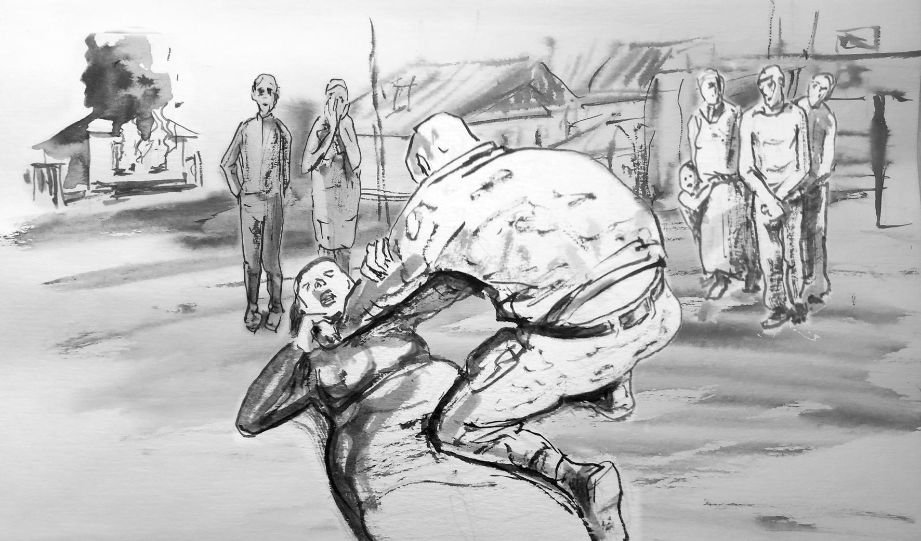

Fig. 7: “(…) ‘You beast, where is your husband?!’ He started to choke me with his hands…” (artist: Serhiy Zakharov)

In some cases, the abduction of a witness was a demonstrative retaliation for the patriotic stance of family members, as in the case of W30(55+), whose unlawful detention was related to her husband’s civic attitude.

W30(55+): “He immediately grabbed me and threw me to the ground. ‘You beast, where is your husband?’ He started to choke me with his hands. I asked, ‘Why are you hitting me, I haven’t done anything to anyone!’ He started to grab me by the throat and choke, and the other one [Russian soldier – ed.] said, ‘Don’t touch her here, people are watching... We’ll take her away and you can do whatever you want there...’.”

W31(25+): “My mother was also taken with us to put pressure on me and my brother.”

W68(55+): “I was terribly afraid of them because it was clear that they had come to torture me. Every word of mine, every move aroused anger in them. I looked at the icon, I was very afraid, so I made the sign of the cross. This gesture triggered aggression in them. One of them sat me on a stool. When I crossed myself, he kicked the stool. I fell, and he hit me in the back with the butt of his rifle so hard that I still have five vertebrae dislocated to this day.
He read me the following sentence, ‘In accordance with Article 222 of the Criminal Code of the Russian Federation, you, [victim’s name – ed.], will be imprisoned in Donetsk.’ I couldn’t understand what I was being accused of and why.”

W41(45+): “They searched the buildings in my yard, I don’t know who they were looking for (...). They said, ‘Take your passport, take some things with you, because you’ll be there for a long time...’ (...) They took all my phones, (...) put a bag over my head, and put me in the car.”

W1(45+): “They all wore balaclavas. They checked my phone. Something didn’t suit them... They pulled the cap down so that I couldn’t see where they were taking me.”

W6(55+): “They searched my house, then handcuffed me and put a bag over my head. They took me to Donetsk.”

9.2 First days of detention

W53(55+): “I found myself in a different world. I didn’t understand how it was possible that just an hour ago you were a free person in your home, a respected, beloved wife, and now you are a nobody…”

W11(55+): “The bag was sealed with tape, I couldn’t see anyone. I only heard voices. They said, ‘Why are you messing around with her; our guys are hungry, let’s give her to them right away…”

W64(35+): “(...) I didn’t understand where I was (...). I was taken somewhere and sat on a bench. I heard someone through behind the wall and realized it was some kind of cell... I sat on the wooden bench for a long time, and my arms and hands, which were handcuffed, were in great pain. I thought I wouldn’t be able to bear the pain any longer.”

W31(25+): “(...) They brought us to the train station in our village. They took us out of the car blindfolded. They lined us up in a row against the wall. They asked, ‘Who was calling?’ [regards phone calls made to Ukrainian-controlled territories – ed.] I realized that bastard was going up to my mother and I said, ‘I made the call.’ It didn’t matter, the main thing was that they didn’t bother my mother. Then it started – they dragged me by the hair and up the stairs... Then into the building itself, to the second floor, up the stairs... During this ‘excursion’ they ripped out my nails; five I left behind on the asphalt, and the rest they started breaking when they sat down…”

9.3 Violation of the bodily integrity of witnesses

Most of the victims interviewed by the Raphael Lemkin Center for Documenting Russian Crimes in Ukraine testify that immediately upon arrival at the sites of illegal detention, they were subjected to actions bearing the hallmarks of CRSV (forcing them to undress, touching their intimate parts, etc.).

W64(35+): “(...) When I was brought to the building where the Russian staff was located, I passed by a line of men; they were shouting, yelling something (...). They touched me everywhere on my body, pulled off my clothes, grabbed my breasts (...).”

W6(55+): “They took the handcuffs off one hand and forced me to undress. They pushed me, laughed... They described my scars, asked whether I had tattoos... Then they said I could get dressed. They took my shoelaces, the belt of my jeans and pushed me into a cell. I learned that it was ‘Isolation.’ I was in Isolation for 50 days.”

W30(55+): “They searched everywhere they wanted, in my underwear and here [witness points to her breasts – ed.]. They told me to lower my pants, they said: ‘We’re checking for drugs.’ I said: ‘What for? Young lads…’, I said, ‘I could be your mother’, abuse…” [witness refers to checking genitals for hidden drugs – ed.]

W17(45+): “(...) They undressed me, examined me, looked at my female organs. They said: ‘There are many like you here – ukropka’ [‘Ukropka’ is a Russian neologism, a derogatory name for female Ukrainians - ed.].”

W41(45+): “I was stripped to the waist, in front of everyone, and checked to see if I was wearing a wire hidden somewhere.”

W31(25+): “(...) They forced me to undress; I sat naked for two hours (...). They touched me with their hands. They were very interested in my personal life. I was in a relationship with a married man, and when they found out, they stripped me naked and doused me with cold water (...). They touched me with their hands: my breasts, genitals, face... I don’t remember that moment, that part, very well, because when I undressed, I mentally switched off; I was absent…”

W9(55+): “(...) ‘Do you have any tattoos on your body?’ he asked. And he started to undress me: he took off my shirt, pants, looked for tattoos (...). And then I felt someone touching my body with his hands – my thigh, my shoulder, my back... I was very afraid that I couldn’t see who was doing it, for what purpose. It was humiliating. He started asking me questions: ‘Are you married?’ I answered, ‘I am divorced.’ (...) ‘Do you have a man? Are you sexually active?’ I did not answer this question (...). They touched my body while they asked each of these questions…’

W17(45+): ‘Then I said to him, ‘What are you doing? I’m a woman, I’m a mother! You can’t do this to me!’ He replied, ‘You’re not a woman, you’re an ukropka’, and added an obscene word…”

9.4 Conditions experienced during detention
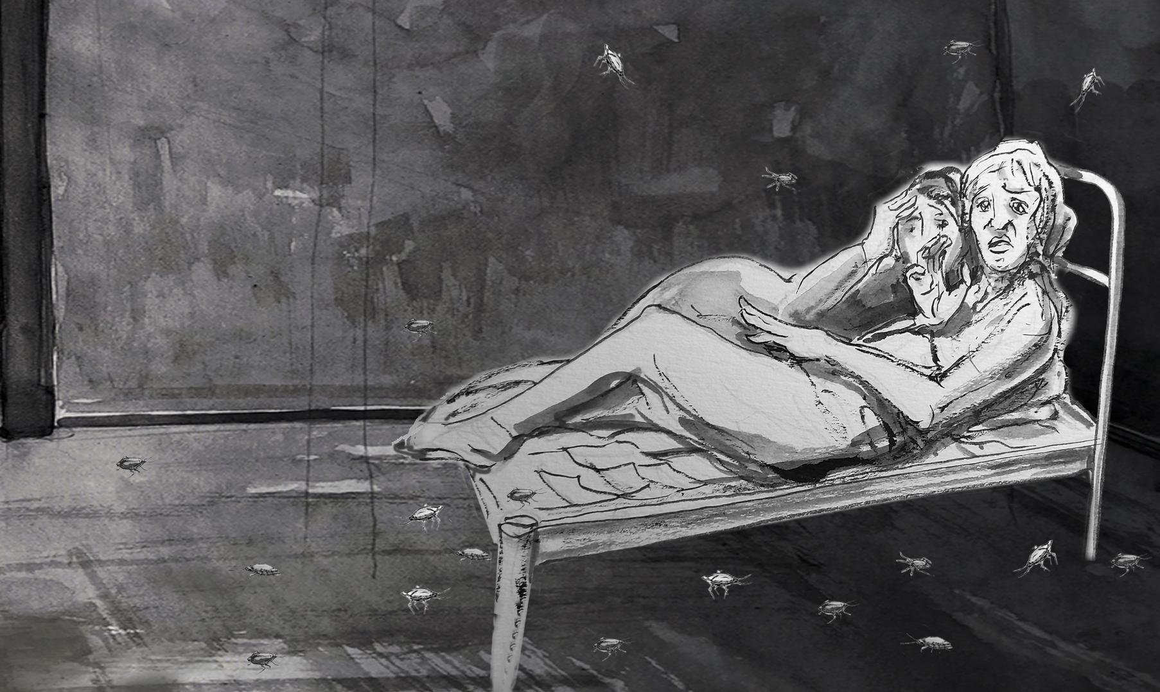
Fig. 8: “I couldn’t go in the top bunk because there were so many cockroaches in our cells... Cockroaches were falling from the ceiling.” (artist: Serhiy Zakharov)
W28(45+): “(...) There were three beds in the cell... They were welded iron plates on legs... There were five of us in the cell. I slept all the time with another woman on the same iron plate... It was very bad for me, I just didn’t sleep almost all night because I have a problem with my legs and I can’t stay in one position for a long time. But I couldn’t go on the floor because there were so many cockroaches in our cells... The cockroaches were falling from the roof. Well, not from the roof, but from the ceiling, there were a lot of them…”

W41(45+): “(...) A solitary cell, about one and a half by three meters; an iron bed was bolted to the floor and there was a damp mattress on it... There was a metal table bolted to the floor, one stool, some spoons, forks, I don’t know... It was all in the cell, and there was a hole in the corner instead of a toilet.”

W6(55+): “(...) You couldn’t sit or lie down there from 6 in the morning until 10 p.m.. You had to stand or walk around the cell (...).”

W11(55+): “We were in the basement of investigative isolation... The windows were covered with sand, you couldn’t see the sun. As soon as it rained, the water in the cell reached up to my ankles... The toilet was not a toilet, it was a hole. There was a sink and an iron table with nails hammered in, an iron bench and a bunk bed. That’s it…”

W28(45+): “(...) Opposite our cell was another cell without windows. This cell was one and a half by one and a half meters. It was for suicide prevention; the whole cell was lined with foam rubber so that a person wouldn’t hurt himself (...). There were never less than four people there; there were always five or six. They couldn’t even sit. They took turns sitting…”

W28(45+): “We had no ventilation in the cell. They just sealed everything up; we were kept without fresh air for several hours and I felt sick... I felt like a sailor in a submarine, like we were dying... I thought, this is the end, I’m just going to die here…”

Access to personal hygiene products

Menstruation. Witnesses did not have access to any hygiene products, so they were forced to use whatever materials were available during menstruation.

W28(45+): “When I arrived at the cell, one woman was menstruating. It was such a problem because she was dripping, and no one had sanitary pads... We tore up the sheets, and then we covered the mattress, because we were afraid that if they saw that we tore up the sheets, we might be punished for it... And then I also started menstruating… out of anxiety... and we didn’t have any more sheets. A neighbor gave us underwear – she just gave them to me, and I rolled them up... We asked the guards, but they said they didn’t have anything like that. They only had condoms if we needed them.”

Access to sanitation facilities

W1(45+): “(...) The toilet leaked, there was a puddle in the cell... The stench... There were flies! Sometimes they gave newspaper instead of toilet paper.”

W6(55+): “A hole in the floor, covered with a rag, and next to it a sink with a tap. It was a very smelly place... This hole was called a ‘diuchka’ and they covered it with a water bottle to tightly cover the hole so there would be less stench and the rats wouldn’t get out…”

W42(45+): ‘(...) I said, ‘I have to go to the toilet, I’m a woman after all!’
‘There is a bucket there.’
‘Give me some water to drink.’
‘Do you think this is a spa resort?’
‘Don’t you understand? I’m an elderly woman!’”

W6(55+): “There was 24-hour surveillance in ‘Isolation’ (...). The camera was hanging there and there was no angle where it couldn’t see you. There was a toilet behind a meter high partition and they could see you sitting on it... There was a sink and a toilet, and I had to wash myself somehow. They could see you... And there were only men there; there were no women among the guards.... And they watched it all…”

W28(45+): “I asked to go to the restroom, and he went with me. I was not allowed to close the door. I couldn’t hold it, I just had to go to the toilet... I had to go to the restroom under supervision, and he was looking at me... He was armed... It was such humiliation... I had never experienced anything like that in my life... I had such a feeling... If I had been beaten, it would have been better... Would have understood that later on, but this is such humiliation… It was physiological process, and this person was standing and watching. What could I do?”

W42(45+): “I have chronic pancreatitis, cholecystitis and diarrhea due to nerves (...). I asked, ‘Can I have paper?’ (...) ‘Do you think this a sanatorium?’ I pulled the foam from the lining of my jacket, and I always keep a piece of paper in my pocket, a newspaper. I said, ‘Give me something, after all, you have toilet paper... you must have something…’ (...) ‘Shut up and sit there!’”

W41(45+): “I didn’t eat just to avoid having to go to the toilet…”

W28(45+): “(...) They brought someone who couldn’t relieve themselves because of the constant stress (...). Then Chechen soldiers were stationed there for two weeks; they were stoned, started beating and taunting them. ‘Are you the one who wanted to complain to someone that you can’t take a shit?’ They forced them to take off their pants. Then they began to push a bottle into their anus... They screamed; it was an inhuman scream... This went on for several hours; in addition, they beat them constantly... And they could not mentally do it [relieve themselves – ed.] in a public place... They took out the bottle. Then they finally did it [relieve themselves – ed.], and they started laughing and made them eat it all... EAT it... That was my first day in ‘pre-trial detention’...”

W14(45+): “They proposed we take a bath.... They didn’t like to hear refusal. When we came out of the cell, there were 3 people standing there, and along the corridor stood 10 Russian soldiers with machine guns... We were led without bags on our heads, so we could see them; they were wearing masks... They started shouting, ‘Eyes down!’ They ordered us not to look at them… When we went to the shower room, the shower was not covered... A soldier was holding the curtain. It was tight and they could easily control us. It was slippery, the water was cold... A fellow prisoner became stressed, slipped and fell. I picked her up, we ‘washed without washing’ and left... A few days later, she had a heart attack and died…”

Restriction of witnesses’ access to food and water

W6(55+): “(...) There were times when for several days they would only give you a piece of bread or cook some black pasta for you (...). Then they started deliberately mixing garbage with dirt, chicken manure with barley... We just had to eat that crap... To this day, I still don’t derive any pleasure from eating…”

W15(45+): “For two days we were starved, we weren’t fed, we had nothing to eat... Then they started feeding us; they gave us feed that they cooked for pigs... But at least the pigs had it cooked. For us, they just poured in some hot water and brought it like that... It smelled so bad and it was disgusting to look at, let alone eat…”

W42(45+): “(...) They threw five-liter bottles of water to us and brought all the leftovers, the remnants that were collected from their tables and the sink (...). That’s how it was for a day, two, three, four, and then I started trembling all over and losing consciousness (...). My legs and hands went numb... Water, half a kilo of bread – the loaves were so small... Water, bread – you would play with the bread in your mouth for a while just to feel like you were eating…”

W11(55+): “They fed me once a day – a piece of bread... They could have given me nothing at all... Well, I didn’t want to speak Russian, so they didn’t give me anything at all... That’s how it was for two weeks... I only drank water and that’s all…”

Health of witnesses and lack of medical care in illegal detention centers for Ukrainian citizens

W42(45+): “(...) They didn’t give any pills, not for my head or for anything else... I said, ‘Give me something, maybe you have some activated charcoal?’ (...) ‘This is not a sanatorium, this is not a hospital!’ I wanted to get at least one pill. My head hurt, my blood vessels constricted, I really could have died…”

W30(55+): “(...) When they took me for the last interrogation, I couldn’t walk. He shouted all the way for me to walk, but I didn’t have the strength. Then they came and injected me with Dimedrol [a strongly sedative drug – ed.] and I fell asleep for the first time in 5 days. They gave me some cough tablets. By then, I was already hallucinating, and when they injected me with Dimedrol, I thought they had given me some truth serum because I was afraid the FSB would come... (...) They said, ‘The FSB will come and get everything out of you…’”

W15(45+): “I had a heart attack, and my left side completely shut down [was paralyzed – ed.]. I couldn’t feel my arm, leg, left side at all…”

W28(45+): “[Regarding the clinic at the illegal detention center – ed.] (...) They just dumped people there who were still alive (...). A person rotted there for two weeks, and they would come every time and say, ‘When will you finally die, you bastard?’ When a body is rotting, you can smell it…”

W1(45+): “We found a tourniquet, 2 ampoules of painkillers, and a bandage in the trash can [in the cell – ed.] (...). And there were blood stains under the bed... People were brought there after being tortured…”

Temperature in the rooms where prisoners were held

W41(45+): “(...) The window was open, and when they brought me in, they told me I couldn’t close it. I asked, ‘Why can’t I close the window?’
‘So that you think faster. And if I see that you’ve closed the window, I’ll pour water on the floor…’
It was still March then, so it was below zero... That night I didn’t sit, I just walked all night so as not to freeze, and before dawn, I had another interrogation, and the second interrogation was harsher…”

W42(45+): “They threw me a torn, stinking, urine-soaked jacket, I put it on myself... My teeth were chattering from such cold that I was at the limits of endurance... First, they took the pillows from the chair; they were also urine-soaked, unbearably fetid, damp, moldy…”

Isolation from the outside world

W16(55+): “A person who first brought a package had their house searched the next day. So even just bringing a package with food was dangerous... You could be punished for that…”

W28(45+): “There was no communication with my family... They didn’t let me make any calls, they didn’t let me tell my family where I was…”

9.5 Interrogations

During interrogations, witnesses were subjected to severe psychological and physical violence by representatives of Russian special services and occupying forces.

W41(45+): “When they brought me in, the first interrogation lasted about 3 hours. There were physical blows a few times, but mainly it was moral pressure... ‘How old are you? You should remember the USSR. What, don’t you want the return of the USSR?’”

W41(45+): “The first question, ‘Do you love Putin?’
‘No…’
‘Why don’t you like Putin?’
I said, ‘Why should I love him? I love my family, my friends, I like sausage, but I don’t love Putin…’ And as I was saying this, he picked up two books, came up, and hit me on the ears for not loving Putin…”

W41(45+): “(...) ‘Sing the Russian anthem!’ I said I couldn’t sing. (...) ‘Tell me the Russian anthem’. I said, ‘I don't know the Russian anthem’. And then they hit me on the head... With their hands, with a book, they might sometimes hit me with a ruler... They beat me with a book on my fingers. I turned my back, and they hit me in the knees... I fell to my knees, and they started kicking me in the kidneys…”

W31(25+): “(...) After the 66th blow, I stopped counting how many times they hit my head against the wall. I don’t know how many there were... Then they took me to a separate room, sat me in a chair, and started interrogating me. Everyone came and asked questions, and when they didn’t get answers, I got punched in the face... Then, when they got bored with that, they took a rope and a bag, made a noose, and dragged me through the room by the neck several times…”

W53(55+): “(...) [A Russian soldier - ed.] tortured me because he wanted me to confess that I was here to spy on him. He thought I was a spy, that I was sent by the Americans to spy on him…”

W1(45+): “The next day, they took me for interrogation (...). They asked me about my daughter, why I didn’t want to live in Russia... They told me they would interrogate me until my daughter came from the Netherlands. They hit me on the head to avoid leaving marks. With their fists, their palms…”

W10(35+): “I always had a bag over my head... When I started to disagree with something, or they didn’t like something, they would put tape around my neck and I just suffocated. After that, I was ready to sign anything. It applied to everyone, if electricity was for the chosen ones, then the bag and tape were for everyone.”

W9(55+): “[A Russian soldier – ed.] said, ‘We don’t see any initiative from your side, we don’t see that you want to cooperate with us. You don’t support us? We’ll help you…’ I felt them putting rings on my hands, on the little fingers of both hands, and his comment about all of this was, ‘This is a lie detector, it will help you remember…’ [regards electric shock torture – ed.]”

W11(55+): “I was interrogated two or three times on Sunday... Each time they changed methods – electricity, shock, rods, water bottle.”

W15(45+): “When they took me for interrogation, they put two clamps on my fingers, at first I didn’t even understand what it was... They put those wires on me and started asking questions…”

W15(45+): “They didn’t blindfold me and when they shocked me with electricity, and I responded to them [answering questions during the interrogation – ed.] they didn’t look into my eyes. They just lowered their gaze or looked elsewhere, but they didn’t look into my eyes…”

W53(55+): “A Russian officer was present during these interrogations. Most of the time the guards beat me. I was tied to the radiator... They kicked me, hit me in the ear…”

W9(55+): “(...) He said, ‘I can help you remember everything, I can put electrodes on your nipples, I can moisten them with water – it will be more effective…’ I started begging him, ‘You don’t have to do this, I’ve told you everything I know. I can’t say what I don’t know…’ And he replied, ‘I don’t know if you know it or not…’”

W68(55+): “They took us to a room where everything was concrete. They forced us to undress completely and beat us with a stream of cold water and electricity. As they said, it was supposed to help refresh our memory, force us to tell them everything. They did it in various ways; sometimes they tortured all of us at once, and then only one person two hours later. They attached live wires to our fingers. They put our feet in a bowl of water and attached wires to our fingers.”

W31(25+): “I was taken to a separate room, where the entire floor was covered in blood... Earlier, I had listened to my brother’s screams for two and a half hours... He was severely beaten... They put electrodes on his ears, and every time I didn’t answer a question, they shocked him for 15–20 seconds…”

W10(35+): “Once I asked the interrogator: ‘Don’t you have any compassion for me, you do realize that neither my husband nor I have done anything, right?’ He replied, ‘Of course, I feel sorry for you; I understand, but why didn’t you pay the ransom right away?’ I asked him how much money was needed. And he replied, ‘50 thousand dollars per person.’ (...) ‘You see, we don’t have that kind of money. Take my cars, my apartment, and let us go. We'll leave here once and for all; we wanted to leave.’ And he said, ‘Well, we’re going to take it all anyway…’”

W9(55+): “I lost hope there... Because they were asking me questions I couldn’t answer... I realized that I couldn’t answer, I couldn’t give them a response, and they would just torture me here until death…”

9.6 Torture

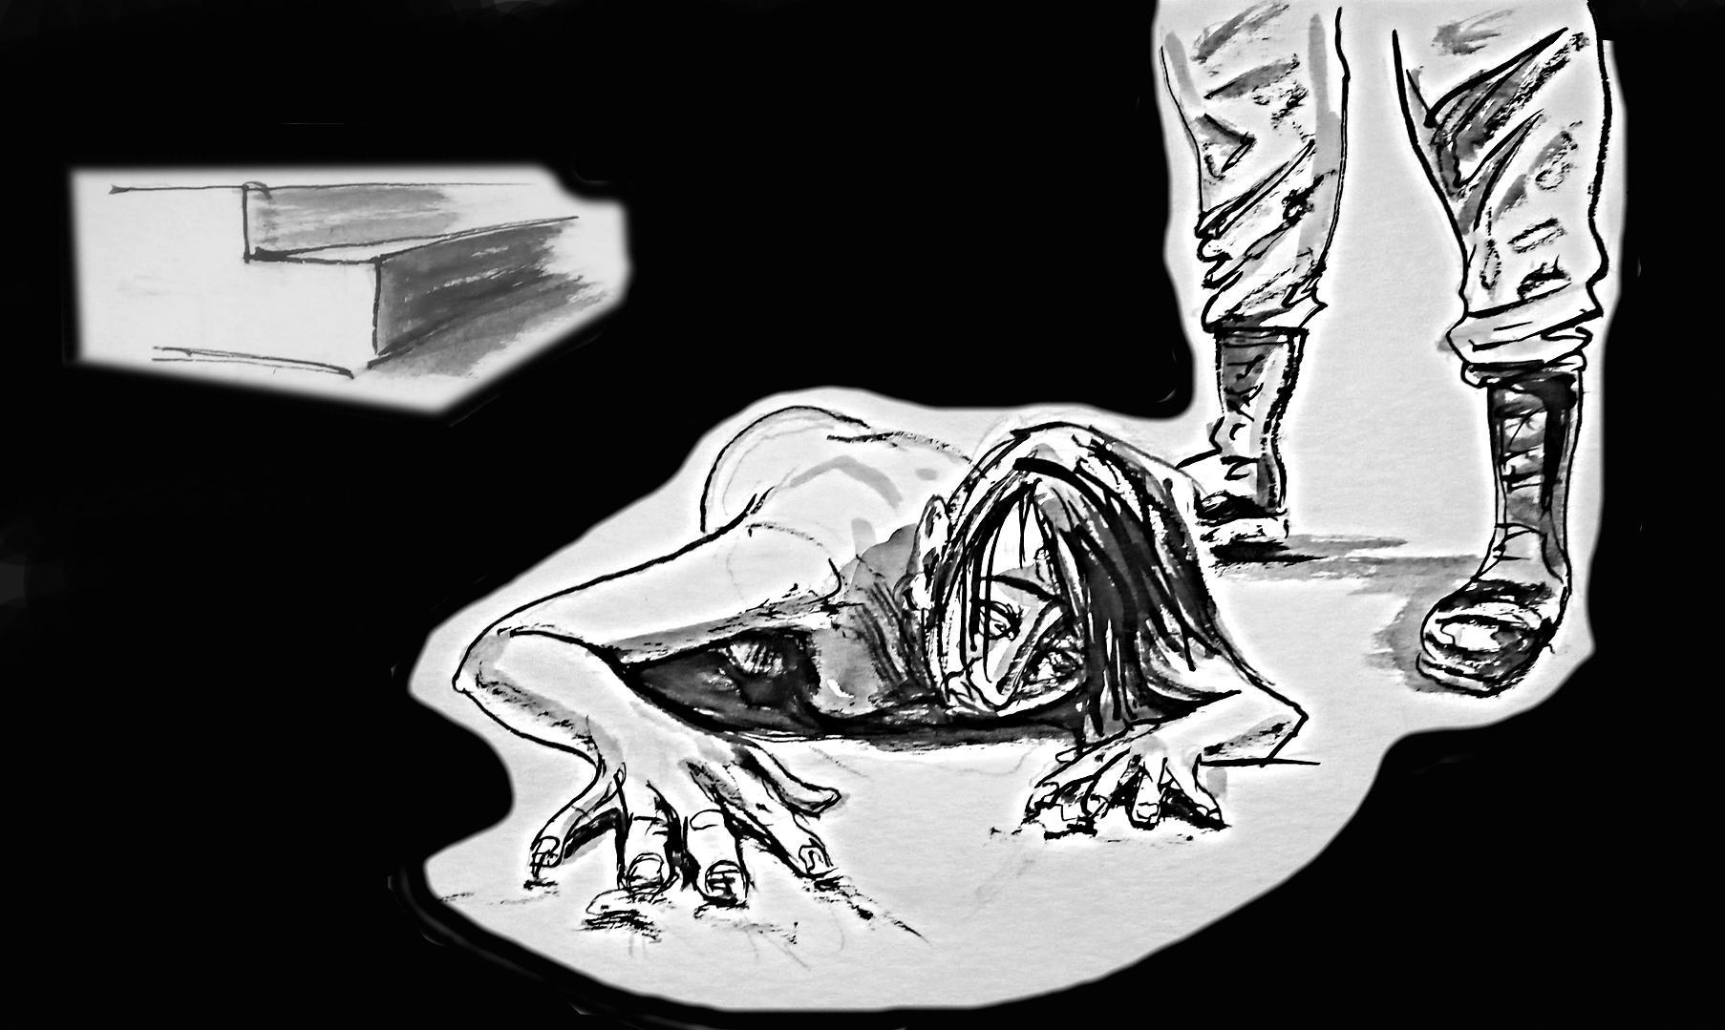

Fig. 9: “(...) They ripped out five fingernails – five fell down onto the asphalt, and the rest were broken off while I was in captivity…”
(artist: Serhiy Zakharov)

W19(45+): “They didn’t need a reason to torture people. I mean, they did it not to gather information, not to punish, but just for pleasure…”

W28(45+): “Upstairs, above our cell, there was a ‘torture chamber,’ downstairs was a ‘torture chamber’ where people were tortured with electricity. People scream differently when tortured with electricity, and differently when beaten... I know those sounds... Depending on how forcefully the gate was opened, I knew what mood the interrogators were in when they arrived. If it was a prolonged sound of opening the gate, I immediately knew there would be interrogations, that they weren’t in a good mood, that they hadn’t gathered any evidence, and they would beat people... And if something was happening outside, for example, a breakthrough by Ukrainian Armed Forces, then they would just kill our men… They vented their anger…”

W11(55+): “They pulled the chair out from under me, lifted me up, and then one of them approached and hit me with a stun gun in the neck... And then they attached wires to my hands, put wires on my legs and wires behind my ears and started shocking me, turning the power up... I lost consciousness there... I woke up when they poured water on me... They started beating me with wire, some thin wire, like braided wire – they beat me with a rod... They beat me in a way that left no traces…”

W15(45+): “When I asked to go to the bathroom, they asked, ‘What happened?’ I replied, ‘I wet myself…’ And they started laughing and saying, ‘Well, that’s good, it’s just like a high, don’t you understand? Give us more!’ And each time they turned up the electricity more and more until I started losing consciousness... I would lose consciousness, they would wait for me to come to, and then start again... It happened three or four times, I don’t remember exactly because I felt very sick…”

W53(55+): “The ‘militia’ separatists kept picking me up and torturing me... It was like entertainment for them... There was this young guy, always smiling... He had this awful smile, like the Cheshire Cat in Alice. He always wanted to spray pepper spray into my mouth. They stopped him: ‘What the hell are you doing?! You’re stinking up the place with gas, we’ll all suffocate!’ But he always carried that spray. He jumped, laughed, cursed at me, pulled me, pushed me by the shoulder.”

W15(45+): “(...) They poured water on people... It was a kind of water torture... They called their victims ‘divers’, covered their noses, held their jaws, and poured the contents of a five-liter bottle into their mouths... They poured until the person choked, then pumped it out and poured again... In my cell, there were two girls who went through this.”

W67(55+): “My cellmate, who was a [Ukrainian – ed.] police officer, was taken away when we were out for a walk. We had never been out for so long. Usually it lasted 15–20 minutes, but this time it was two hours. Then the guard came out to us and said, ‘Do you shave?’
‘No.’
‘Well, today you’re all going to get razors, so make sure all of you are shaved down there.’
We were surprised that they could give us dangerous razors when previously they wouldn’t even allow us to keep a fork. And suddenly they gave us razors...
We entered the cell and saw our fellow inmate, she was all disheveled, all wet. Her eyes were red and bloodshot. She had just returned from interrogation. We saw her thigh with marks from the stun gun. She told us that they laid her on a chair against the wall, and every time they hit her head from one side, she hit the wall from the other. They abused her. They stripped her naked. They threatened her: ‘We’ll find your child and bring it to you in pieces’. They wrapped her hands in a wet cloth, handcuffed her, and shocked her, her wrists were black. Then they laid her on the table, took off her panties, and said they would give her to soldiers who would bite off her nipples. When she was naked, spread out like a star on the table, they asked why she wasn’t shaved in her intimate areas. Then we all got disposable razors and were told to shave.”

W15(45+): “Even before Ukrainian Independence Day, my cellmate, came back from interrogation like one big bruise... It was horrifying, it was awful to look at her... Her wrists were bruised from the handcuffs, blue-black-red, with wounds... Her entire left leg was burned by a stun gun... They poured water on her, beat her on the chest, on the breasts, here between the breasts, where the solar plexus is... She had burns from the stun gun on her back... Then they tried to cut off her little finger with a knife... They stripped her naked, threatened to rape her. They took off her clothes and said, ‘We’ll take you to a place where there are many hungry soldiers, and they will rape you there…’ She had bruises in those places because they laid her on the table and pulled down her trousers.”

W53(55+): “(...) It was after the first interrogation (...). Well-equipped, big Caucasian men grabbed me by the hair, handcuffed me, and dragged me down... It was incredibly painful because my arms were constantly being twisted... I fell, and they lifted me up again by those handcuffs and dragged me to the ground floor room. Again, they started kicking me. Then many horrible things happened. I just covered my ears and head so they wouldn’t hit me with their hands on the head. Then they started kicking me in the butt, and I fell face down on the floor... I was already on my knees. It was complete horror…”

W12(45+): “I never thought something like this could be done to a human being... You’ve already taken me prisoner, I’m a civilian, a defenseless woman, and you do something like this…”

Psychological torture

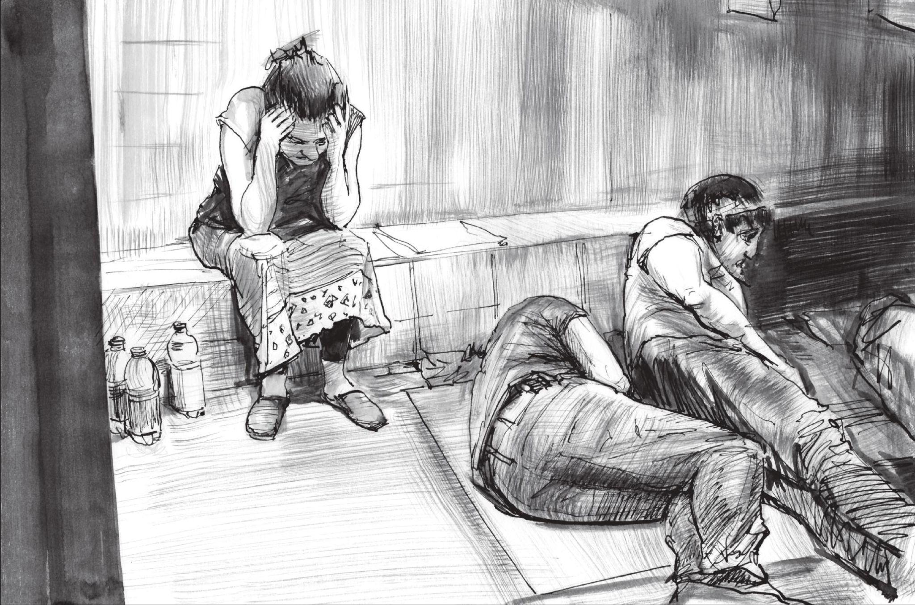

Fig. 10: “We heard the screams, we heard when they were beating us – groaning, torturing people… and every time we sat together and waited until they came for us…” (artist: Serhiy Zakharov)

W12(45+): “We cried every day. Not a day went by when we didn’t cry, and there wasn’t a single day when someone wasn’t beaten, mocked…”

W9(55+): “(...) There were rooms, either five or six (...). They took me to one of them and sat me down... There were two tables, on one of them lay a stick, a wooden hammer, a gas mask, some metal clamps... On the other table was some unknown device with wires, two wires, and on the right side, the entire wall was covered with bloodstains... I was there for about half an hour. I was very scared because I didn’t understand what they wanted to do with me... And this room... And these devices…”

W15(45+): “A Russian soldier slammed the door behind me and said, ‘Don’t let her sleep at night, don’t call a doctor, don’t allow her to receive packages, don’t let her go for walks!’ Those were his orders concerning me…”

W6(55+): “(...) You can’t see anything [with a bag on your head – ed.], you just walk, constantly listening if someone is approaching from behind or from the side; you just stick with the group, because you know that at any moment you could be hit…”

W1(45+): “[A Russian soldier – ed.] threatened me: ‘You’ll lie on my floor and piss yourself…’”

W65(65+) [male – ed.]: “A drunken guard opened the cell window and asked: ‘They’re asking you if you can fuck a woman in front of us?’ Two minutes later, he asked, ‘Can you fuck a guy in the ass?’ I have a lot of hatred towards them... They humiliated me; they didn’t touch me physically, but I’d rather they beat me than ask me such questions…”

W68(55+): “Before leaving home, I put a blister of blood pressure pills in my pocket. So that when I felt such great pain that I couldn’t bear it anymore, I would take them all to lower my blood pressure to zero and die. Just so I wouldn’t feel this humiliation anymore.”

One of the methods of exerting psychological pressure on unlawfully detained civilians was forcing them to listen to the sounds of other prisoners’ torture.

W6(55+): “You’re witnessing people screaming constantly…”

W12(45+): “We heard people being tortured, killed; what they did to them... We heard them mocking and raping boys... And all this happened behind closed doors... They didn’t even have to touch us... It drove us crazy just hearing it all day long, and at night…”

W53(55+): “Maybe it’s even easier when they beat you than when they torture a person and you witness it... That was also incredibly terrifying…”

W9(55+): “They tortured people... We heard the screams, we heard when they were beating us – groaning, torturing people… and every time we sat together and waited until they came for us…”

Victims of illegal detention informed the Raphael Lemkin Center for Documenting Russian Crimes in Ukraine about threats to the safety of their loved ones, including sexual threats.

W56(M): “They threatened my mother that they would rape me and then cut me into pieces in front of her... That they would send me ‘round and round’... [referring to group sexual violence against a minor – ed.]”

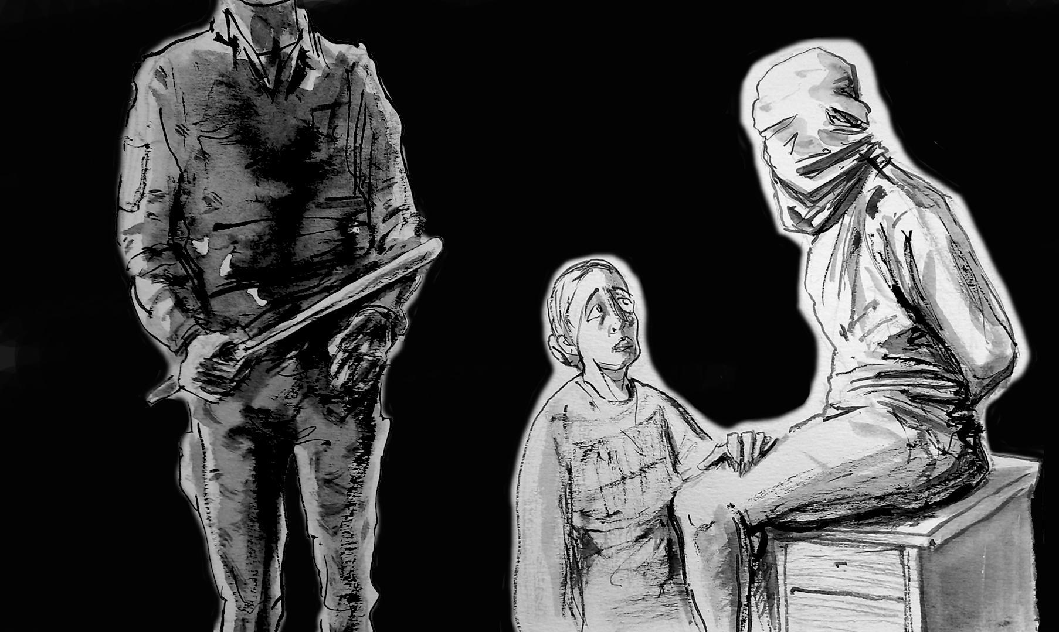

Fig. 11: “They brought me my husband with a black trash bag over his head… He could hardly walk… He said to me, ‘I love you. Stay strong…’” (artist: Serhiy Zakharov)

W2(35+): “(...) They pulled out a gun and told me to kill my husband (...). ‘We can’t do it, but nothing will happen to you if you do. We’ll let you go.’ I burst into tears... (...) ‘I really don’t like it when a woman cries. It makes me want to hit her hard!’ They brought my husband with a black garbage bag over his head... He could barely walk... They sat him on a stool... (...) ‘Now we will help him…’. They took off the bag, washed him, stitched him up without anesthesia, he lost consciousness... I think that was also a kind of manipulation. They bandaged his head... His whole head was covered in bumps, his face... He said to me: ‘I love you. Stay strong…’ I replied: ‘I’ll wait for you.’ And they took him away…”

W15(45+): “[A Russian soldier asked his colleague – ed.] ‘When are we taking her to Donetsk?’ and the other replied, ‘I don’t know, maybe at the end of this month, and we’ll take the whole family. We’ll shoot them, and let her sit there.’” [The witness recalls a conversation between Russian soldiers during convoy – ed.]

W30(55+): “They said, ‘We’ll get your children, tip off the FSB as to the whereabouts of your children…’ I had a nervous breakdown hearing that... I couldn’t bear the pressure and said, ‘Just shoot me already, I can’t take it anymore... I don’t want to live like this anymore... Why mock a person like this?’”

W15(45+): “They forced my child to say everything they told him. ‘Did your mom get money from Ukrainian armed forces?’ He replied, ‘No, my mom didn’t get any money.’ They shocked him... He agreed: ‘Yes, yes, she did…’ So they took my child’s testimony... Then they led him out, stood him in the doorway. He stood there crying... They held him by the neck and said, ‘Tell your mom what you wanted to tell her…’ My son replied, ‘Mommy, please, tell them everything they ask about... It hurt me a lot…’ They said, ‘Do you want to feel more pain like that?’ ‘No.’ ‘Do you understand what you have to do?’ And with such a smile... [about torturing her 19-year-old son – ed.] They threatened me by telling me that in the ‘temporary detention facility’ there was a cell where men were raped... [Russian soldiers threatened to rape her son – ed.]”

W53(55+): “And they blackmailed me, saying, ‘We’ll rape your daughter, a virgin, 100 times one after the other…’”

W36(45+) [male – ed.]: “They beat me, then said they’d bring my 18-year-old daughter and 20 people would rape her (...). They’d take my blindfold off and rape her... And it would be on my conscience... One of them called a soldier and ordered loudly, ‘Bring his daughter here!’ In 15–20 minutes, the soldier returned and reported that the daughter had been brought... They said, ‘Let her wait for her fate…’”

W2(35+): “They threatened me... They said my dad was in the room next door... [although it wasn’t true – ed.]”

W31(25+): “They said they would bring my mom soon and shoot her right in front of me... They are not human! They really are not human!”

One of the forms of psychological torture commonly used in places of detention for illegally detained Ukrainian citizens were staged executions.

W30(55+): “When they took me away, they said, ‘Where are you going? To be shot?’ And they laughed... I didn’t know what was going to happen to me, I was scared…”

W53(55+): “He pulled out a gun... I lay face down on the floor... He put the gun to my temple and said, ‘I’ll shoot you, you bitch! I’m sick of you, you’re waste material!’ And then he, well, I think he pulled the trigger... But my brain died for a very long time... The investigator later asked me if a shot was fired, but I don’t remember anything... My brain considered it as death... I simply didn’t exist for some time…”

W31(25+): “Machine gun to the ribs and ‘We’ll shoot you now and that will be the end of it…’”

W53(55+): “Some Chechen guy came... He said something to them in their language, which I don’t understand. Then he said something in Russian. ‘Step aside, I’ll shoot her in the kneecap…’ He moved away from me about 10 meters... There was a curb, and he lay on the asphalt and put down his assault rifle. I started screaming and jumping out of fear... I thought my kneecap would burst any moment... It was an incredibly terrifying moment... Then he fired somewhere – into nothing – and they started laughing. (...) ‘Look, did she shit herself or piss herself? What stinks?’ And this was the third or fourth day of interrogations, and no one had given me any food or water…”

W10(35+): “They also told jokes like, ‘Get ready, there’s going to be an exchange today!’ They took the prisoner, took him somewhere, brought him back and said, ‘It was a joke.’”

W16(55+): “No one explained anything to us... No one told us why we were there, how long we would be there, why we were there at all, what happened to our families... We didn’t understand what was happening around us, we had no information... It was very frightening, very, very physically and mentally difficult... It was like a kind of sophisticated torture that lasted indefinitely and you didn’t know when it would end…”

Threat of rape

Witnesses interviewed by the Raphael Lemkin Center for Documenting Russian Crimes in Ukraine constantly heard threats from representatives of the Russian occupation forces regarding future gang rapes.

W30(55+): “(...) The first week I did not sleep at all, and then a little (...). I was even afraid to turn over on the bench, because I thought they would immediately open the door, approach from behind... I was very afraid of taunting and intimidation…”

W60(45+): “[A Russian military officer – ed.] constantly made fun of me... He pulled up my shirt... He tugged at my breasts, saying, ‘This one is already used, you can only fuck her in the ass…’ But I didn’t care anymore... I was beaten so many times that my whole body hurt... Overall it was a very scary time…”

W53(55+): “I was alone in a room with about 15 Ossetians, men... Even just being in that room was terrifying for me…”

W17(45+): “I was exhausted, I was afraid... A soldier led me down long corridors. When he opened the cell, he pressed me against the wall by my neck. He grabbed and touched my body painfully... It was very painful... And he said the following words: ‘I will need you today... You have to…’ I took the bag off my head and saw a huge man wearing a balaclava... The only thing I noticed was his blue eyes, he was over 1.8 m tall, he was huge... It was clear from his speech that he was a Russian military officer. (...) ‘Don’t go near the window... If you look, you’ll be shot in the forehead. At night, when they come for you, you have to go back to the door, put on a bag and keep your hands behind your back…’ I was shaking all over.”

W53(55+): “(...) ‘You, bitch, you are in our debt; you gave so much money to the Nazis (...). You brought them food... We won’t kill you because our people are returning from Ilovaysk and need to relax... We will take you there for the night…”

W1(45+): “(...) “If you answer with a lie, we will hand you over to the Chechens (...). You have no idea what they will do with you…”

W53(55+): “They said, ‘Have you even seen a pussy that has been fucked all night? Have you seen a pussy that has been through so much? Just go there for the night and we’ll bury you in the ground…’. And this line, ‘...we will bury you in the ground…’, was repeated many times…”

W34(35+): “Then one of them said, ‘She will tell us everything... I’m going to bring your daughter here, I’m going to cut her, I’m going to kill her, and you’re going to watch…’ (...) They tied my hands, and their commander said, ‘It’s okay, we’ll ‘pass her around’ and she’ll tell us everything.’” [referring to group sexual violence – ed.]

W38(35+): “[The Russian soldier – ed.] came again, the children were already sitting... He said: ‘If you don’t talk, I’ll aim at you and so I’ll hold you at gunpoint, and you’ll all take turns fucking your own mother…” I made the sign of the cross... And in my mind I said: ‘Let them rape me already, as long as they don’t beat my children…’”

W6(55+): “[One of the guards at the site of the witness’s unlawful detention – ed.] threatened to send me to the militia for ‘relaxation’... There was a barracks on the second floor. He said I was too old to be treated that way... But I had a ‘workable mouth’ and he showed me what I was supposed to do…”

W6(55+): “I asked, ‘What are you holding me for and what do you want from me. Are you holding me because of the way I think? I’m not going to think differently, I’m not going to give up…’ And he said, ‘You are smart and talk a lot. Your mouth is going to be busy today, because the guys need to be satisfied…’”

W39(35+): “[Russian military officials – ed.] told me, ‘We can get any information we need. But since women have a higher pain threshold than men, we won’t beat you. There are other methods... I will call our Chechen foreman. He will bring his whole team and talk to you. But don’t think you’ll like it; it won’t be like you think... There are other ways. For example, this bottle…’ And when you’re sitting there and he’s telling you all this, of course it’s terrifying…”

Sexual violence as torture

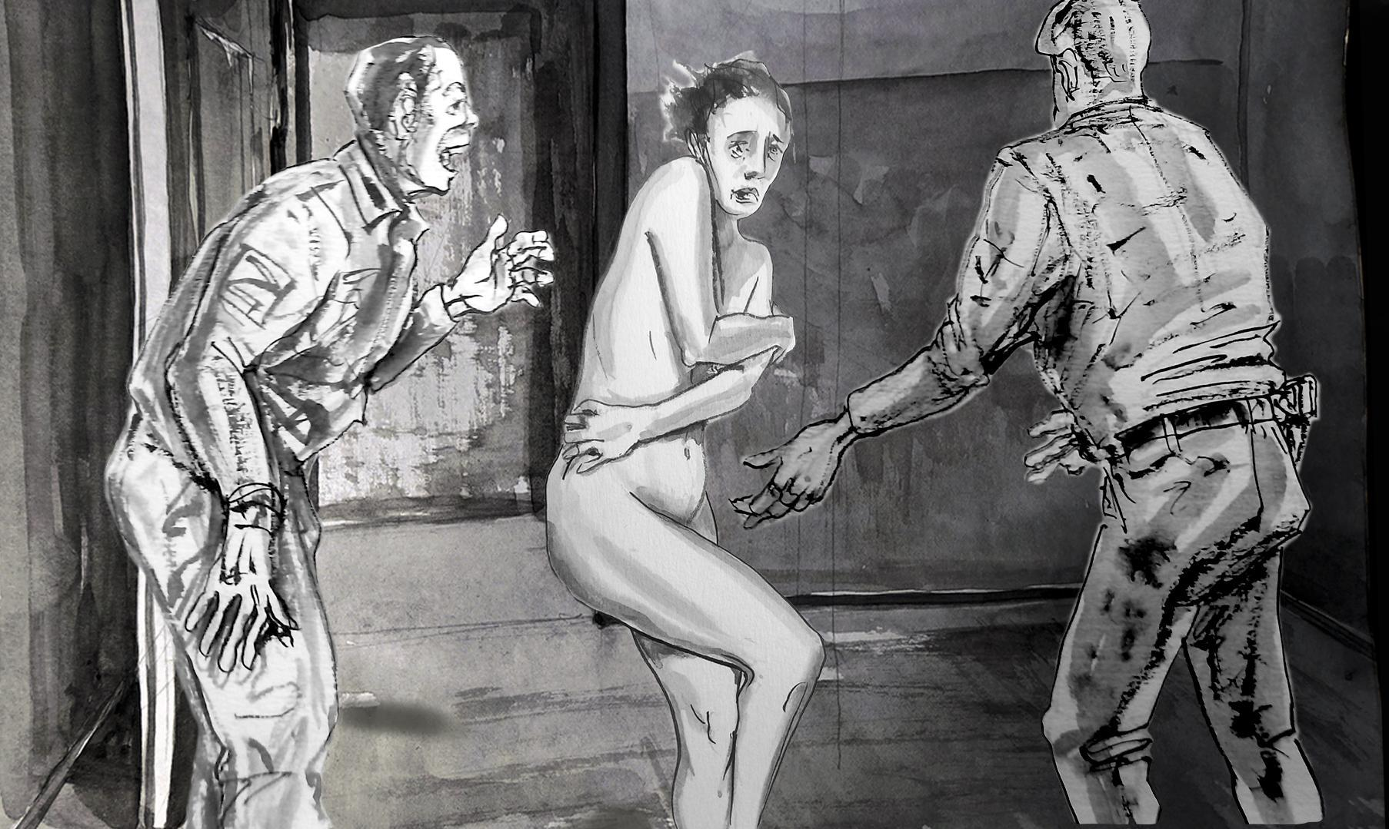

Fig. 12: “They threw me out of the cell at 7 a.m…. They touched me deliberately to humiliate me…” (artist: Serhiy Zakharov)

W59(35+): “They started undressing me again... He unbuckled my belt and started to take off my trousers… I’m not able to recount all these details…”

W59(35+): “I was blindfolded. I heard the door open, someone entered... This person covered my mouth. He knocked me over... and that was the first rape. I screamed, tried to escape…”

W17(45+): “They threw me out of the cell at 7 a.m, we lined up, facing the wall, and they touched me again... They smiled, ‘Ukropka sits on this…’, and they deliberately touched me to humiliate me…” [victim refers to intimate places – ed.]

W30(55+): “He came, brought water, pulled his genitals out of his pants, tried to persuade me to take it in my hands (...). He tried, he tried… to put it in my mouth, and I tried to avoid it as best I could…” [Shows how she pushed the rapist away with her hands – ed.]

W41(45+): “At night, two or three people came to me and tried to rape me. The first time I was very scared, because he [the Russian soldier – ed.] came with a gun. I stripped down to my waist and bent right and left [under duress – ed.]. ‘I’m a grown up, I know you’ll kill me later because you’re armed, but I’ll bite off everything I can if you want to try it.’ There was a second and third attempt... The same guy came three times that day. Different people came, but the worst was the first day, because he came with a gun. He stripped me, pushed me, harassed me, beat me and tore my clothes... And the second and third time he came without a gun, he harassed me…”

W64(35+): “Then there was this situation in the duty station. One of the rebels kept coming up and looking at me through the bars. I thought he felt sorry for me... I told him, ‘I’m very thirsty.’ (...) ‘Do you want to go to the toilet?’ I replied that I did... And he led me to the toilet. It was a public toilet... There were cubicles there. I leaned over the sink, turned on the tap and began to drink the water. At that moment he put my head in the sink and began to undress me and press me from behind... He said: ‘Shut up bitch, or I’ll cut you…’ And then someone started walking down the corridor and talking loudly, and he let me go. He even pulled up my pants himself. He took me by the hair and pulled me. I managed to take maybe two sips of water. And he dragged me back to the cell…”

Witnesses interviewed by the Raphael Lemkin Center for Documenting Russian Crimes in Ukraine also testified about sexual violence against men.

W53(55+): “(...) I saw through the bars how they were dragged a man with his pants down. I don’t remember his face, I remember that he had his pants down. And they dragged him a little further, he was somewhere nearby. I saw those who stood with their backs to me – those militia collaborators... And this prisoner screamed terribly, because they began to rape him... And he groaned so much... And then someone from the crowd began to say, ‘No, not here, not here, drag him to the cell…’ When he started groaning, it was so frightening that I covered my ears, my head and my eyes so I couldn’t hear…”

W35(45+) [male – ed.]: “They took off one guy’s trousers and said: ‘we’ll shoot your balls off!’ And that’s what they did…”

W33(25+) [male – ed.]: “They asked us to put the Jew on a bottle (...) They put the bottle down and said, ‘If you don’t put the Jew on the bottle, we’ll come in 15 minutes and beat the shit out of everyone…’ (...) ‘Anally, so he sits down and it goes up his ass…’ And they said, ‘You have 15 minutes to do it…’ What could we do? We’re not animals... Then they came back, ‘Oh, the Jew isn’t on the bottle, well here’s what you get!’ and they kicked us in the ribs…”

W28(45+): “(...) I heard it four times (...). I don’t know how many there were, maybe there were more in the cells…” [Answer to a question about the total number of rapes of men unlawfully detained by representatives of the Russian occupying forces – ed.]

W12(45+): “One man was raped. I don’t know what they used, but they put a condom on, raped him, raped him, then took him out... And they made him eat the condom and everything that came out of it…”

W28(45+): “I witnessed the rape of a man. They took him and raped him in the corridor... The orcs brought two people specially. They were people from the Kherson region, convicted criminals.... They were kept in a separate cell and given condoms to rape these men in a public place…”

W68(55+): “There was a girl with a very beautiful figure. They were all raping her. She had long red hair. She reminded me of an actress. When I asked her why she was there, she replied that her brother was in the Armed Forces of Ukraine and that’s why they took her. For six months they carried her with them. For six months they raped her. She was about 35–36 years old. They took her again and again and brought her back after some time. It’s hard for me to even talk about it. You could see from her that she just didn’t want to live anymore.” [The witness claims that Russian military representatives held the woman as a sex slave – ed.]

W6(55+): “It was simply a form of torture... They did not derive sexual pleasure from it, it was just torture... Like the beatings…”

10. The appearance and nationality of representatives of the Russian occupying forces who committed crimes against women.

W68(55+): “I woke up early and baked poppy seed buns, which I took to my elderly neighbors. I returned home and there they were – Rosgvardiya, as they called themselves. They were crazy, abnormal men. I think they were on drugs. They behaved horribly. I was very indignant – I am an adult woman, and they simply came to my house. I am a woman, and you come to my house. Who are you? You come to my country, to my village, to my house and lay your dirty hands on me.”

W31(25+): “They were all residents of Luhansk, they were all from Luhansk. I said, ‘You did everything to make people hate you; even my great-grandchildren will hate you.’”

W44(75+): “They stayed here until the end of March… They would come… They took turns every day. Some were like this, others were like that… Some were Buryats, others were narrow-eyed…”

W22(45+): “(…) On 7 March [2022 – ed.] the troops arrived: green uniforms, white bandages on hands and legs. That Chechen came to me (…).”

W23(75+): “People from the DPR came right away… The militia who fought in the Donbas came. The residents of Donbas. They fought among themselves (the so-called ‘people’s militia’, i.e. local collaborators, and the Russians). However, the Russians themselves would say, ‘Without the support of the local militia, we wouldn’t have achieved anything…’ The militia set up their own checkpoints, their own authorities. And then the Russian soldiers came…He would often come with Babai [a famous Russian mercenary from the Caucasus – ed.] and steal diesel fuel from us. (…) I don’t remember him well, but when I opened the door, I knew from his posture that he was one of them…”

W24(35+): “He was short, black-haired, had stubble and a rifle that was too big for him… He reeked of vodka. Maybe after 8 March… (…) Danylo was a tank soldier, for he stank of diesel fuel…”

W27(45+): “He had a Caucasian face and bloodshot eyes…”

W25(25+): “They were Buryats.”

W9(55+): “The one who interrogated me had oriental brown eyes and a voice I would still recognize. I will never forget those eyes. I will remember them for as long as I live…”

W26(55+): “They were Russians. They spoke some other language with one another, but they spoke Russian with us. But they weren’t Buryats. They had narrow eyes, but they were of another nationality (…). They all looked the same.”

W45(65+): “Not a Buryat, a Russian – a ripped, strong one. His phone rang and I heard the name of Romek.”

W3(25+): “Mostly Asians… They had such names…”

W5(M): “We had Russian flags and flags with Kadyrov’s face [on the streets – ed.].”

W53(55+): “A Russian officer was present during the interrogations. He was dressed differently, he had red hair. He was a typical redhead, with a freckled face and red hair. He hardly ever spoke to me. Sometimes he was present during the interrogations; he would sit in another corner, writing. I was always sitting opposite him; sometimes he would raise his eyes and look at me. On the third day they wanted to inject me with some yellow drug. They said it was a truth serum, after which I would become a vegetable – I would tell them everything, but I would become a vegetable. I asked that officer, ‘Tell me, why should I love your Putin?’, and he laughed and replied, “Who says I love Putin? I hate him.’ And I thought, ‘Then why are you here?’
Sometimes he spoke with the investigators; he had a pronounced Russian accent, this is why I say he was Russian. He was their superior, he was giving them some orders.”

11. The physical condition of witnesses following the crime. Medical documents.

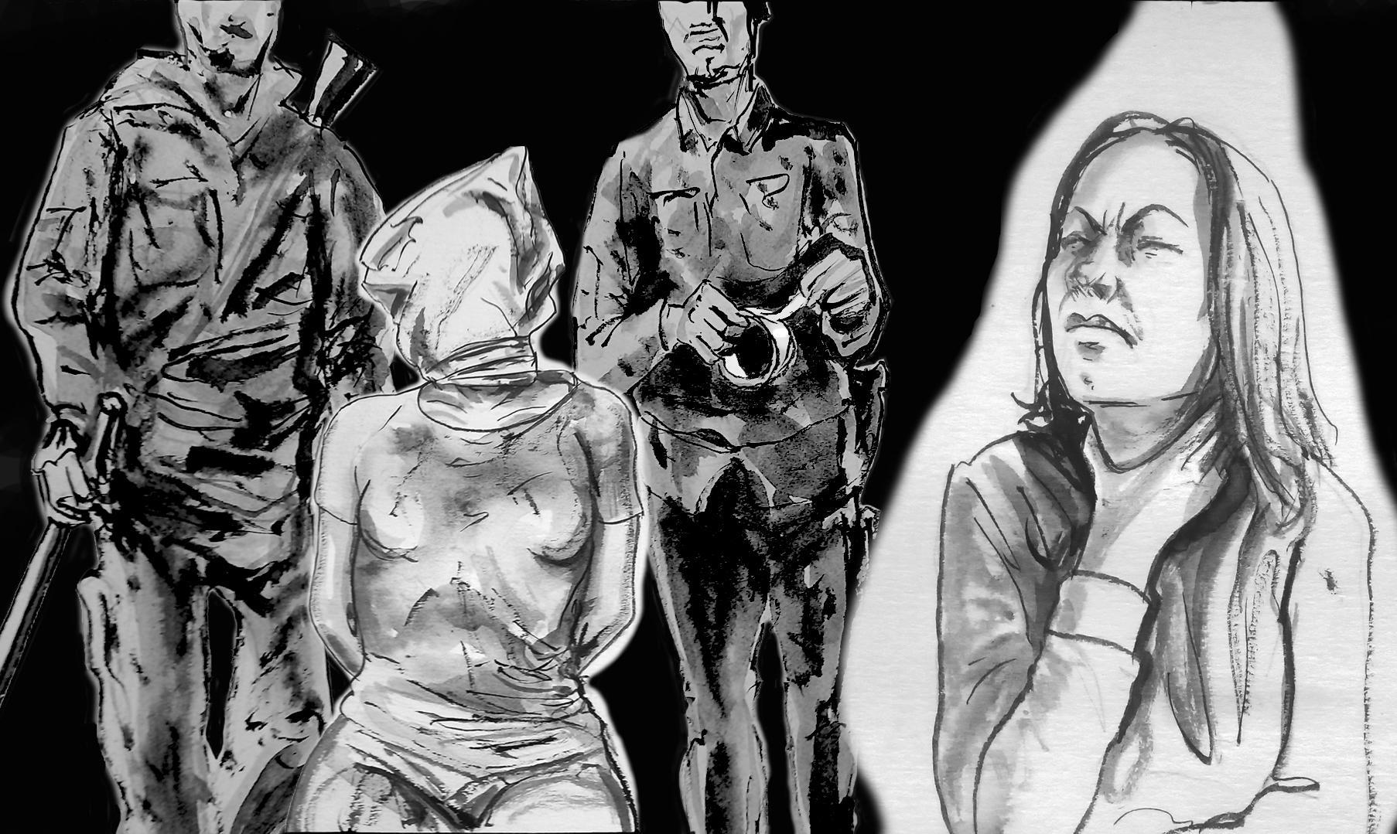

Fig. 13: “A very commonly used form of torture is choking” (artist: Serhiy Zakharov)

Injuries caused by the Russian Army have an irreversible impact on the health of witnesses interviewed by the Raphael Lemkin Center for Documenting Russian Crimes in Ukraine. Victims report serious physical and mental health problems: a range of reproductive health issues, sexually transmitted diseases (which were transmitted by soldiers of the Russian Army), various psychosomatic ailments, circulatory disorders, and also lung and liver diseases.

W20(55+): “I was in such a state... I was bleeding... It hurt, obviously.... It hurt more and more. It began to burn. I bled all those days...”
W16(55+): “During my imprisonment I lost 27 kg, my skin was sagging and all my muscles whittled away...”

W9(55+): “I developed thrombophlebitis. I have never seen anything like it, even though I worked for many years in the ambulance service. I saw veins coming out of my body, veins turning into cords – tumors and ropes. My doctor recommended an ultrasound examination of the blood vessels of the lower extremities, so I underwent the tests. He kept on repeating that these were the consequences of torture with electric shocks, with electricity. And what he saw on my heart, and what had happened with my blood vessels and blood [the victim underwent medical examinations once released from her illegal arrest – ed.]”

W30(55+): “(...) After that, I can’t hear... Stress, shock, the hallucinations were strong, very bad... I suffer from insomnia... I can’t sleep, I feel cold... I have arthritis; my hands hurt, my feet hurt... My carotid artery was damaged by a Russian soldier who choked me...”

W10(35+): “A very commonly used form of torture is choking... I still can’t recover, I think I’m suffocating... Psychologists work with me, but it is still difficult... I wake up at night because I think I’m not breathing. And it’s been six months since the exchange and my return from captivity.”

W23(75+): “He choked me with such force... I couldn’t swallow for two weeks, I had to drink just a little water... (...) Before the war, I weighed 75 kg, and now I weigh 60 kg...”

W31(25+): “(...) My neck was cut because of the choking. I was all bloodied [she points to her neck and chest – ed.] My head was very swollen.”

W6(55+): “(...) I have a lump on my back (...). After being beaten... It needs to be removed, I need surgery.”
W53(55+): “(...) He [a representative of the Russian occupation troops – ed.] kept calling me out and saying: ‘Stand up straight!’ He would back up a few steps and then leap forward and kick me in the solar plexus, right between my breasts. This threw me onto the wall of the small cell, and I hit my back against the wall... At first you can’t breathe... There is a spasm in the diaphragm, you start to suffocate, you can’t breathe. And then you take that long-awaited breath. But the pain is terrible. Like a fire in your chest, inside, accompanied by a terrible burning sensation... (...) Then he would go somewhere, come back after a while, and say again: ‘Bitch, come here, stand up straight!’ And another kick from his boot... I survived these blows maybe 5 times... When they released me, my breasts were all blue and yellow. And now this disease, oncology, has appeared in the same place where he hit me. I will never be able to prove to anyone that this tumor was caused by the beating... And all this had its consequences.”

For some victims, the consequence of the crime committed by soldiers of the Russian Army was an unwanted pregnancy.

W27(45+): “(...) I got pregnant after that (...). My period was late... I took a pregnancy test. I didn’t have sex with anyone, I figured out that it was they... [The witness states that she did not have sexual intercourse other than the rape committed by representatives of the Russian occupation forces – ed.]

One of the witnesses provided the Raphael Lemkin Center for Documenting Russian Crimes in Ukraine with a medical report from an examination conducted a year after the sexual assault.
Consultative medical opinion: The diagnosis was like a sentence: Chronic hepatitis C, genotype 3.

W45(65+): “(...) And now this disease, it was he who infected me... [chronic hepatitis C – ed.] And I’d never been sick with anything before.”

In the absence of any medical care, with pharmacies and medical clinics closed, victims of rape tried to protect themselves from infection by any means available.

W20(55+): “(...) There was no hot water... No laundry soap... There were antibiotics in the home medicine cabinet... Maybe I got infected...”

W23(75+): “I ended up in the hospital, beaten up...
– What happened to you?
– I fell into the basement...
The next day my head was pounding. I vomited...
I had a concussion... I stayed in the hospital... [In the weeks following the crime – ed.] The pains began, the liver pains... They found a cyst in the liver and the early stages of tuberculosis. Maybe the bastard had tuberculosis...”

One of the problems victims faced when trying to obtain medical care in the temporarily occupied territories was the fear of encountering collaborators in medical facilities.

W23(75+): “(...) I was afraid that I would run into a collaborating doctor (...).”

W43(55+): “(...) There was nowhere to go for medical care (...). When I asked the Russian military for a doctor, they said they only had doctors for the military – not for civilians.”

W15(45+): “(...) Because of the Russian Federation, I now have problems with my back, legs and eyes, female problems, stomach ailments, my teeth have started to fall out, and atopic dermatitis has spread through my body (...).”

12. The mental condition of witnesses following the crime.

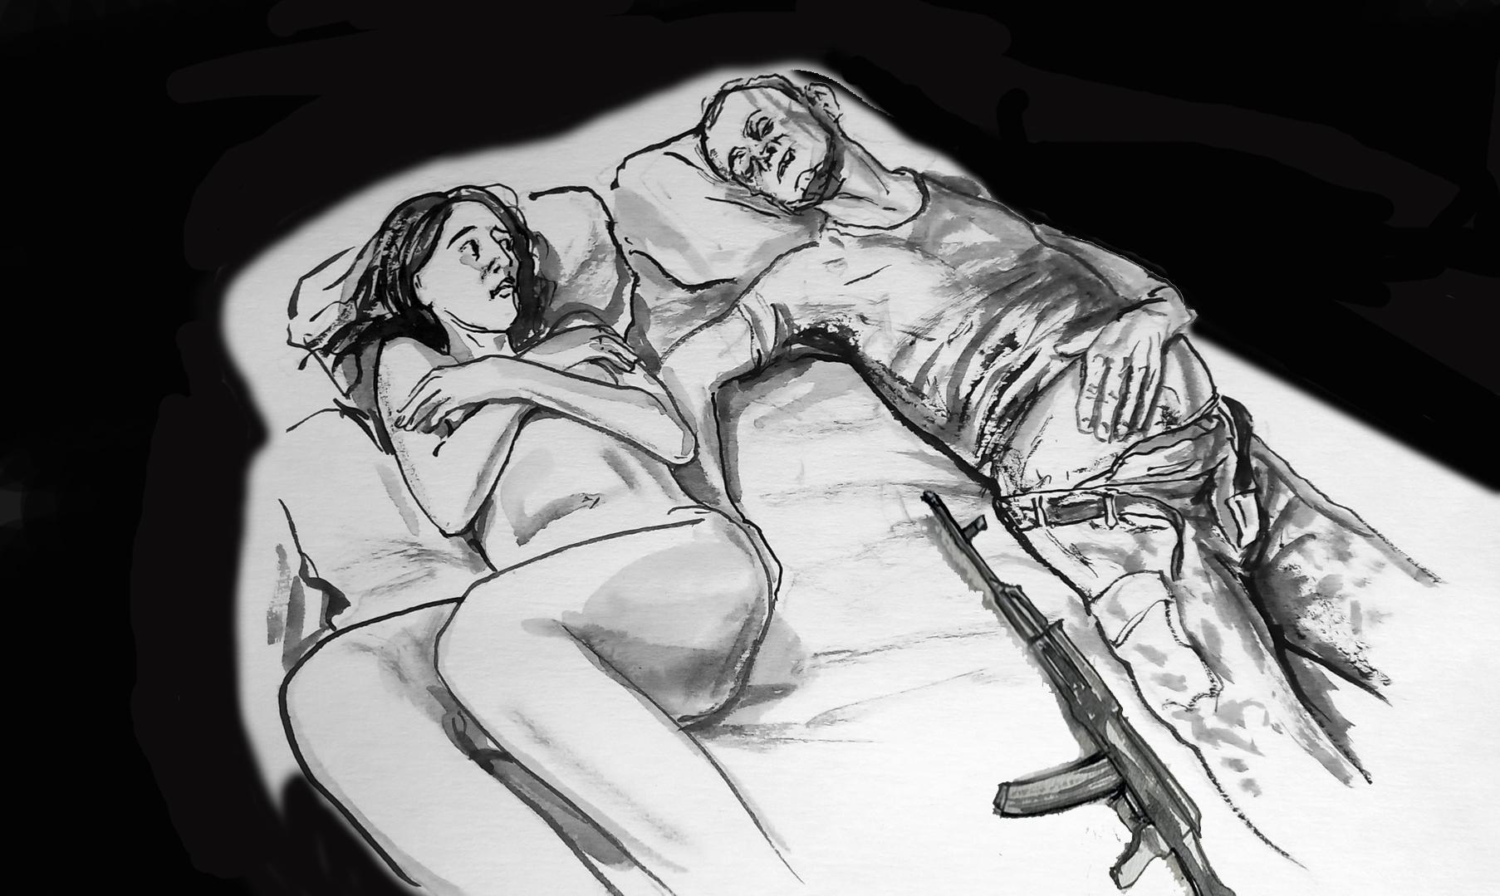

Fig. 14: A victim of rape committed by the Russian Army (artist: Serhiy Zakharov)

Crimes against the sexual freedom of witnesses have resulted in deep psychological trauma. The women surveyed exhibited symptoms of post-traumatic stress disorder, including sleep disorders, panic attacks, dissociation, hallucinations, delusions, strong feelings of guilt, apathy, as well as difficulty in communicating and performing basic household tasks.

W9(55+): “I lost hope... I stopped eating, I tried to lie down... I wanted God to take my soul, because I didn’t want to look at this any more.”

W24(35+): “(...) It wasn’t a dream... I thought they were looking for me. A neighbor came around, I was even afraid of her, I don’t know why.... A car with the invaders drove by – I hid. I would hide in the barn... I would hide wherever I could... I was unable to recover for three days...”

W20(55+): “I thought I was going to be killed. For having witnessed [a crime – ed.].”

W22(45+): “I still can't sleep. I still only sleep after taking sleeping pills.”

W53(55+): “The mind wants to survive, to protect itself, to not go crazy. And it [the mind – ed.] itself blocks out certain details, memories. I don’t remember most of the faces of my torturers, I couldn’t remember them after just a week of being released. Later, when I found these people on the Internet, I recognized them, but my mind erased them from my memory, so that they would not come to me at night.
I understand that a person has to testify as quickly as possible, because the mind tries to erase the terrible things, and many details fade in testimony.”

Witnesses of the Raphael Lemkin Center for Documenting Russian Crimes in Ukraine turned to medical facilities with complaints about their deteriorating health, such as victim W45(65+). Reported symptoms: Constant anxiety, bad sleep, weakness, discomfort, constant crying. History: violence, June 2022.

W45(65+): “(...) I don’t sleep, I don’t cry (...). My sleep is disturbed – I don't sleep at all... And in the morning I want to sleep, but I have to get up. My psyche is obviously disturbed... I keep on shaking. When I get into the house now, I see him [the rapist – ed.] standing in the doorway...”

W68(55+): “I keep on having the same bad dream. I dream all the time of the Russian who took me away from home. I still dream this, because I remembered his face. He kept rubbing his hands like this [shows gesture – ed.]. It was clear from him that he just wanted to wipe me off the face of the earth.”

W9(55+): “I did not expect that I would stop sleeping altogether. I was very afraid, because I thought they were everywhere, that they would put a bag over my head and take me away...”

W6(55+): “(...) I find it difficult to sleep... It's been a little over a year since I was released, but I can only sleep when someone is in the room. I can’t eat normally... Those smells... You’re being choked... And the tobacco... And the stench from the toilet... And the bugs... My husband’s cooking, and I shout out: “Close the door!”. I don't cook anymore.”
W62(65+): “(...) And at night, when I was alone, I apologized to my family. To everyone, one by one. I talked to my husband and asked for forgiveness for cheating on him. And I betrayed my promises, to be with him for the rest of my life, that he would always have a washed shirt and fresh food. I promised it to him. I thought that being a good housewife, a good wife, was very important. But the war came and destroyed everything! My life, my outlook on life and my vision of what a family should look like.”

W31(25+): “(...) Sometimes I wake up from it at night (...). From the memories... It’s disgusting, disgusting, awful.... How they undressed me, touched me, groped me... A Russian soldier then told me: ‘Now you will never be able to have sex with men again.’”

W46(35+): “(...) We had already entered Ukrainian-controlled territory, but I was asleep and dreamt of his eyes.... I don’t remember his face, I remember his eyes... I often have a feeling of déjà vu that they are taking my hand, I’m shaking... [I shiver – ed.]”

W44(75+): “And my daughter tells me that a neighbor shouted: ‘Don't kill me!’ I went to my neighbor, and she was barely alive... (...) ‘I will tell you, but no one else...’ She told me everything, everything... How she begged, how she ran, how she escaped... (...) ‘Mother, it could have been worse...’”

One victim feels guilty that representatives of the Russian occupation forces killed her husband when he tried to protect his wife from sexual violence.

W44(75+): “(...) My daughter was worried (...). She didn’t cry... She had no tears, nothing... She stood over him [the body of the slain man – ed.] ‘Why didn’t I leave first? It’s my fault.’ While I said: ‘Don’t blame yourself.’ She really blamed herself.”

The victims isolated themselves from their families and from society, and could only communicate with those who had experienced similar trauma.

W59(35+) : “I experienced very terrible things, but I never said anything to my husband. And he never said he knew, he heard anything...”

W2(35+): “(...) I felt like it didn’t affect me, that seemingly nothing had happened to me. It was like watching a movie. My mother asked me:
– Did they do anything to you?
– They didn’t do anything, but I don’t want to talk about it...”

W44(75+): “She cried and screamed in her room. And then she started going to the neighbor... She didn’t want to be here, she went to the neighbor... [W24(35+) – ed.]”

W25(25+): “The worst thing was when I came back... I saw the condition of my loved ones. Then I started to be very afraid for each of my family members. Of course, I didn’t tell them what was going on...”

For the victims of the Russian occupation army, being in places associated with the crime was psychologically difficult.

W44(75+): “We had journalists from Austria. They said: ‘We’ll take you.’ And she said: ‘No, no... Where will I leave my mother?’ And then a week went by. I saw that she was feeling bad, very bad... I said: ‘All right – let’s go!’”

Witnesses giving testimony to the team of the Raphael Lemkin Center for Documenting Russian Crimes in Ukraine stressed that the crimes of the Russian occupation army against women should be known to the whole world.

W28(45+): “(...) I didn’t cry once while I was there. I knew that when I was released, I would sit in a corner and cry just to get it off my chest...”

W28(45+): “I set myself up that I had to get out of there alive. In order to come out of this alive, I had to be prepared mentally. There was no limit to what those bastards could do, but I had to pull through irrespective of the circumstances....”

W23(75+): “I sit and cry... I gave my tears complete freedom... No one shouts anymore: ‘Shut up!’ I never thought that this could happen to me... I want to shout at the whole world...”

W43(55+): “Criminals must be punished according to both human and divine law!!!”

13. Citizens of Ukraine who are still held captive.

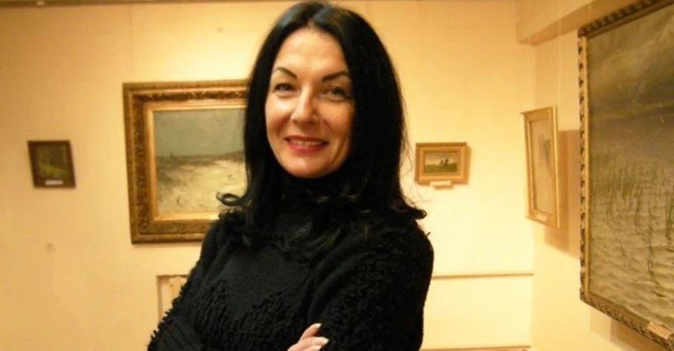
Olena Pekh, born 1971, is an art historian and research fellow at the Museum of Fine Arts in Horlivka.
(Photograph from her daughter’s private collection.)

There is no accurate data on the number of women held in the Russian Federation and the temporarily occupied territories of Ukraine, but it is estimated that thousands have been illegally detained. One of them is Olena Pekh, who since 9 August 2018 has been illegally held captive in the prisons of pro-Russian separatists in the temporarily occupied part of the Donetsk Oblast.

Her only crime was that when the Russian occupation of her hometown had begun, she did not renounce love for Ukraine, her homeland. A sham court of the internationally unrecognized so-called Donetsk People’s Republic sentenced Olena to 13 years in a penal colony in the occupied town of Snizhne, Donetsk Oblast, for “treason” – because she refused to call the quasi-republic her homeland.

Isabella Pekh, the prisoner’s daughter, gave her testimony to the Raphael Lemkin Center for Documenting Russian Crimes in Ukraine in order to bring attention to the fate of Olena Pekh and many other citizens of Ukraine who have spent years in Russian torture chambers. The daughter obtained her information from other prisoners (fellow prisoners of Olena Pekh) who managed to regain freedom. Below we publish excerpts from Isabella’s testimony.

Isabella Pekh: “My grandmother, who stayed in the occupied territory in the Donetsk Oblast, suffered a stroke in 2016. We lived in Odesa, in the territory controlled by Ukraine, but my mom had to go and take care of grandma. We knew that it was very dangerous to go to the Russian-occupied territories, but we had no choice. During one visit, armed men came to the house, handcuffed my mother and put a sack on her head. They took her to a military base and held her there for five hours. Then they put her in a car and started to abuse and push her, and they also beat her over the head; they took her to occupied Donetsk… (…) They placed her in a cell that looked like a punishment cell. She received neither food nor water and did not get permission to go to the toilet. They ordered her to write a declaration that if she returned with any injuries, she would make no claims against these soldiers.
As soon as they reached their destination, they dragged her from the car across the ground, up the stairs and into a room. They put a sack on her head and started to strangle her. When they realized that the end was near, that she could not take it any longer, they let her go… This torture was constantly repeated… She was electrocuted, after which she started to bleed black and pass clots of blood. She was severely beaten and had bolts driven into her knees. My mother suffers from epilepsy; during torture she had four epileptic seizures, during which it was forbidden to help her.”

Isabella Pekh: “(…) I received a call 10 days after her arrest. A man whom I did not know told me that my mother had been arrested. When I asked him why she had been arrested, he replied, ‘I cannot tell you. I don’t want to be in the cell with her.’”

Isabella Pekh: “(…) My mom was repeatedly tortured (…). She was taken for an execution (…). There were two mock executions. She was tortured, they put a gas mask on her head and began to beat her; she had no access to oxygen, she was choking… She was repeatedly raped…”

Isabella Pekh: “(…) The torture made my mother attempt suicide (…). She found some corroded object. I don’t know what it takes to make a person who loved life so much consider such a step… She had it thought through… She asked for a bowl of water. She was tearing at her veins, and to speed up the process, she kept her hands in the bowl. They found my mother covered in blood. They gave her an injection, bandaged her hands and left her there. The whole cell was covered in blood…

(…) My mother wore a Star of David necklace. The Russians realized that she was Jewish and started to call her a Jewess in a mocking way. One of the Russian soldiers cut the star off with his knife.
They enjoy humiliating people in various ways… I think that all those who participate in inflicting torture should be punished. The perpetrators should be brought before court. They shouldn’t pretend that they don’t know what is going on and what they are doing…Many of them took pleasure in it. This is why I say that their actions are conscious, deliberate and intentional. They know exactly when to stop. They know exactly when and how to pump a given person. They know how to prevent the victim from dying during torture, so that they could continue it without killing them.”

Isabella Pekh: “(…) After years of imprisonment, my mom is in a critical condition. She doesn’t receive appropriate medication for diagnosed epilepsy. She doesn’t eat properly, her legs are virtually destroyed after all the torture, her hip joint is damaged. She doesn’t sleep all night, she tries to walk despite pain in order to avoid paralysis, which is very likely.”

Isabella Pekh: “(…) There are still many places where Russians have been keeping Ukrainian civilians for years; these places have long been known to both the Ukrainian side and international organizations (…). These places are simply soaked with tears, pain, grief and fear.
They have no right to detain civilians. These people should never be detained. There are no mechanisms for liberating such persons as part of exchanges. Even if there are some options and strategies, they simply don’t work. Only a miracle can change the situation; international organizations and the international community should take appropriate action to help bring civilian hostages home and not let them die in Russian prisons, where they are tortured and condemned to death. Only international pressure on Russia can save my mom.”

Afterword
Since the very first days of the Russian occupation of the Donetsk and Luhansk oblasts of Ukraine, the local patriots have been suffering illegal arrests, detainment and various kinds of torture.
People are held in warehouses, garages, police stations, prisons and basements. In all places of illegal detention, there are many cases of rape and torture against civilians.
Since the full-scale invasion on 24 February 2022, the number of cases of violence, especially sexual violence against women, has grown exponentially. The Kyiv Oblast was the first of the most affected regions where, while documenting Russian crimes, we encountered a huge number of cases of rape against local women by the Russian occupation army. As the Russian invasion expands, we keep receiving more information about the affected women.
The report contains testimonies of women who were imprisoned by the occupiers and subjected to inhuman torture. They also talk about those women who disappeared in Russian torture chambers. Sometimes the prisoners who witnessed the death of other inmates did not even know their surnames. During my detainment, the occupiers repeatedly threatened me with murder, saying, “We will bury you at a landfill site and nobody will ever learn about it.” Maybe one day we will discover the mass graves where those tortured to death are buried.
This report shows authentic experiences, emotions and voices – voices of the war that began in 2014.
The consequences of our traumatic experiences will stay with us forever. It does not matter how many years have passed; captivity never lets go. We grapple with its effects every single day. The majority of women who were held captive cannot sleep in the same room with another person; those who were in solitary confinement cannot sleep alone. You dream that you are in a cell, and that someone will come and take you for an interrogation. Paraphrasing a famous saying, former prisoners repeat that “you can take a woman out of captivity, but you cannot take captivity out of a woman.”
Ever since 2014, the behavior of the representatives of the Russian occupation authorities, as described in the testimonies, proves that violence – including sexual violence – is an integral part of the occupiers’ lives. The enemy has transplanted this way of life and behavior into the occupied Ukrainian territories with complete impunity.
I have been interviewed about my experiences a great number of times. Sometimes it seems to me that I remember better what I said in an interview that what actually happened. My brain wants to survive, to protect itself from insanity. It hides the details. For instance, only a week after I had been liberated from Russian captivity I did not remember the faces of my torturers – my brain was protecting me from their “visits” at night.
Today, on the basis of my own experiences, I know that the witness has to testify as quickly as possible, because the mind tries to erase the horrible things, and many details fade in testimony. We have to inform the world about the crimes with which Russia still terrorizes Ukrainian civilians as soon as possible.
I would like to point out that many women who experienced sexual violence are elderly persons. When we document their testimonies, these women often say that they might not live to see the perpetrators punished. But even if the victims will not live to see the perpetrators punished, the accounts collected by the Raphael Lemkin Center for Documenting Russian Crimes in Ukraine will testify to the suffering about which humanity can never forget, lest it repeats in some time in another country, lest the future generations experience it. We all have to work towards putting a stop to violence, so that those who consider committing new crimes be sure of impending punishment.
Nobody can punish these criminals as we can do ourselves: with our honesty, with the truth we tell to the world. Even if we will not live to see the perpetrators punished, our testimonies will remain and eventually will serve to punish the criminals.
Iryna Dovhan
Documenter at the Raphael Lemkin Center for Documenting
Russian Crimes in Ukraine

Appendix:
А1. Legislative and regulatory framework

Criminal Code of Ukraine
Article 152 of the Criminal Code of Ukraine. Rape
Article 153 of the Criminal Code of Ukraine. Sexual violence
Article 187 of the Criminal Code of Ukraine. Brigandism
Article 154 of the Criminal Code of Ukraine. Compulsion to sexual intercourse
Article 155 of the Criminal Code of Ukraine. Committing acts of sexual nature with a person under sixteen years of age
Article 156 of the Criminal Code of Ukraine. Debauchery of minors

Criminal Code of the Russian Federation
Article 131 of the Criminal Code of the Russian Federation. Rape
Article 132 of the Criminal Code of the Russian Federation. Violent actions of sexual character
Article 133 of the Criminal Code of the Russian Federation. Compulsion to perform sexual actions
Article 134 of the Criminal Code of the Russian Federation. Sexual intercourse and other actions of sexual character with a person who has not reached the age of sixteen years
Article 135 of the Criminal Code of the Russian Federation. Depraved actions

International law
A request seeking authorization from a Pre-Trial Chamber of the International Criminal Court to open an investigation into the situation in Ukraine
Factsheet: the unique characteristics of SGBV (Sexual and gender-based violence) committed during armed conflict, OBWE

Declaration on the Protection of Women and Children in Emergency and Armed Conflict, UN, 14 December 1974

Legislation on violence against women, UN, 2010
Rome Statute
Geneva Conventions
International Committee of the Red Cross. Women facing war

Council of Europe Convention on Protection of Children against Sexual Exploitation and Sexual Abuse
Istanbul Convention. Council of Europe Convention on Preventing and Combating Violence Against Women and Domestic Violence

Coordinator: Monika Andruszewska
Documentation and field work: Monika Andruszewska,
Iryna Dovhan, Victoria Godik, Roman Taibov

Head of the Raphael Lemkin Center: Jarosław Bittel

Editors: Kateryna Zhuk, Oksana Vodopyanova, Iuliia Miziukina,
Maksym Bondarenko

Translation into English: Translation Department of the Pilecki Institute
Author of graphics used in the report: Serhiy Zakharov

